Teachers’ notes Level B1.2

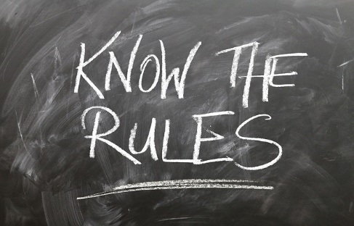
Lesson outcomes
By the end of the lesson students will have:
- talked about their classroom expectations.
- grouped their ideas.
- compared and written their ideas.
- created a final list of expectations for the school year.

Materials
Handout for students
PPT
www.projectideal.com (reference for the teacher)
Images taken from Pixabay.com

Time | Procedure | Materials
10 minutes | Activity 1: Brainstorm  - Display lesson objectives.  - Explain that with today’s lesson students will establish a set of classroom expectations discussed and compiled by themselves.  - Explain what you mean by expectations. Standards of behaviour and how we treat each other. Ref: ProjectIDEAL (informing and designing education for all learners) (www.projectideal.com).  - Distinguish rules from expectations (on the Ppt)  - Students divide into groups to brainstorm their ideas, both positive or negative and then to write a list.  Ideas will depend on previous experience and ethnicity but will probably include:  Be nice; don’t make fun; bring all the right materials to class; don’t laugh at people; don’t hit; don’t kick; don’t steal; be quiet; don’t fight; take care of school property; don’t write on the desks; don’t write on the classroom walls; help each other; don’t shout out in class; stay out of trouble; don’t say bad things; arrive on time; don’t eat or drink in the classroom; tidy the room at the end of the lesson; concentrate on the lesson; don’t all speak at once; put your hand up if you want to ask a question; speak one at a time; listen to the teacher; listen to your classmates. | PPT
15  minutes  15 minutes  15 minutes | Activity 2: Group the ideas  - Ask students to share their ideas together. Write the list on a board or overhead screen for everyone to see.  - Can they now put these ideas into groups? Go through the list and circle some similar ideas in the same colour,  - eg. hitting, kicking, fighting in one group (eg. in green); writing on the desks, wall, leaving litter on the floor in another(eg. red), teasing, making fun in another (eg.yellow), positive ideas like concentrate, be nice, listen to the teacher in another (eg. blue).  - Tell students to look at the language box which will give them some useful expressions to use.  - Tell them to continue this activity in their groups and then go through them all together.  Activity 3: Reduce and regroup.  - Work with the students to reduce further the number of ideas into groups. Introduce the terms respect, tolerance and behaviour. Tell them to look at the glossary. Eg. respect for each other, respect for property, respect for the teacher, tolerance of those who don’t agree with you, tolerance for each other’s ideas, tolerance of other’s views and respect for them. Listen, collaborate and punctuality could be other expectations.  - Post headings on the board or flip chart and allow students to place their ideas in appropriate categories either by writing on the board or attaching “post-its”.  Activity 4: Display  - The final list of expectations should be displayed in some way. As a poster, a declaration, a leaflet or simple written list.  - Let students decide how to do this in their groups and ensure each student keeps a copy of the list. | White board or flip chart. Coloured board pens. Post-it notes.
5 minutes | Reflection  - Do students agree with this idea of collaborating on classroom expectations?  - Does anyone disagree or think another way is “better” eg. the teacher being more authoritarian or imposing punishment for bad behaviour?  - What experience do they have from the past?  - Invite comments.

Students’ handout

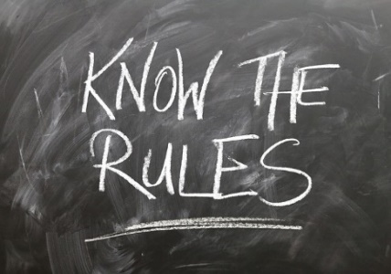
Lesson Outcomes
By the end of the lesson you will have:
- talked about your classroom expectations.
- grouped your ideas.
- compared and written your ideas.
- created a final list of expectations for the school year.

Activity 1: Brainstorm
- With today’s lesson you will establish a set of classroom expectations discussed and compiled by yourselves.
- The teacher will explain what we mean by expectations.
- Get into groups and brainstorm any ideas you have, both positive or negative and then to write a list.
Activity 2: Group
- Share your ideas all together. The teacher will write the list on a board or overhead screen so everyone can see it.
- Check the language box for useful phrases.
- Put the ideas into groups. Start going through the list all together. Circle some similar ideas in the same colour, for example ideas about being nice could be circled in red, ideas about keeping the classroom clean could be green, and so on.
- Now continue this activity in your groups and then go through them all together.
Activity 3: Reduce and regroup
- Work with your teacher to reduce further the number of ideas into groups.
Look at the glossary. Your teacher will help you with some words.
- Post headings on the board or flip chart and place your ideas in appropriate categories. Either you can tell your teacher what to write, each group can take turns writing on the board or you can write on post-its and stick them on the board under the best heading.
Activity 4: Display
- Decide how to display the final list of expectations. It could be as a poster, a declaration,
a leaflet or simple written list. Talk about it in your group and make sure all of you keep a copy!
Reflection:
- Do you agree with this idea of collaborating on classroom expectations?
- Does anyone disagree or think another way is “better”, like the teacher being more authoritarian or imposing punishment for bad behaviour?
- What experience do you have from the past?
- Invite comments.
Glossary
Remember these:
Respect (verb) (noun) = to have regard for the feelings, wishes or rights of others.
Tolerate (v) = to allow without interference, the practice of something you disagree with or dislike.
Collaborate (v) = to work together on a project or activity.
Listen (v)
Behave (v) = to conduct yourself within the acceptable norms of society
Behaviour (n) = the way you act towards other people.
Be punctual = to arrive on time.
Punctuality (n) = being on time.

Language Box:  Making suggestions  - Why don’t we ……?  - How about (putting ) ….. ?  - I suggest we …  - Shall we ….  Eg. why don’t we put be nice in the group with respect for other people?  How about putting together don’t shout and don’t speak all at once?  I suggest putting respect your classmate, not be nice to them …..  Shall we make a category for being on time? | Agreeing and disagreeing  - In my opinion this is a really important expectation.  - What do you think about putting…?  - I think ….  - I think it’s a good idea ….  - Do you think …. ?  Eg. In my opinion behaviour is really important! Yes I agree with you!  What do you think about putting don’t bring food to class with food and drink to class?  Yes, that’s a good idea!  Do you think putting don’t kick and look after school property together is okay?  I’m not sure. I’d prefer them to be separate.

