Teachers’ notes
Relationships Roles in the Family B1.2
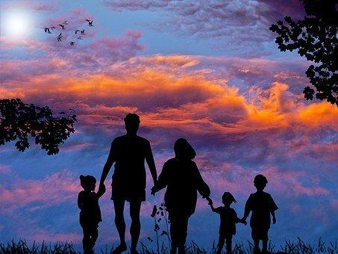
Learning outcomes
By the end of the lesson students will have:
- read about the roles of different family members in 2 families
- considered how roles in the family have changed over the years
- speculated on how these roles may change in the future

Materials
Student handout / PPT
All images taken from www.pixabay.com
Appendix 1 – reading texts A and B

Time | Procedure | Materials
5 minutes | - Display and clarify lesson objectives.  - To engage learners and generate interest, ask students to think about how families have changed over the last 50 years and make suggestions. Suggest they think about:  - size of family/number of children  - who does what in and out of the house  - the role of the parents | PPT
20 minutes | - Tell students they are going to find out about a family from 50 years ago and a contemporary family.  - Divide the class into two groups. Give one group Text A and the other Text B.  - Ask each group to read their text and complete the notes table on page 2. | Activity 1
10 – 15 minutes | - Once they have finished, pair students up so that there is someone who has read Text A and someone who has read Text B in each pair. Tell them to compare their answers and complete the table noting any differences.  - Conduct whole class feedback asking students in particular whether there is anything that surprises them. Do they think that most families today lead similar lives to the Rasmussens or do they know families who are more like the Garcias? Does where you live make a difference? Ask them how similar the families are to their own families.  - Focus on the vocabulary in the glossary so that all students have been exposed to all the vocabulary items. | Activity 2
10 – 15 minutes | - Tell students to look at Activity 3 and ask them to match the sentence beginnings to the ends.  - Check the answers with the whole class.  [Answers: a) 3, b) 1, c) 5, d) 2, e) 4]  - Ask students to discuss the sentences in small groups. Before they do this, focus on the language in the language box. You will need to explain that ‘speculating’ means ‘guessing about the future.’ | PPT  Activity 3
5 minutes | Plenary  - Conduct a plenary and ask students to reflect on how things are likely to change in the country where they were brought up. Do they think moving to a new country has had/will have an impact on the roles within their own family? | Activity 4

Relationships Roles in the Family
Learning outcomes
By the end of the lesson you will have:
- read about the roles of different family members in 2 families
- considered how roles in the family have changed over the years
- discussed how these roles may change in the future
Activity 1: Families now and then
Read the text you have been given. Use the information to complete the table below.
Notes
Family size
Work
Housework
Advice and Help

Activity 2: Changes in Families
Work with someone who read a different text from you and make notes on how the families are different.
Family size
…………………………………………………………………………………………………………………………………………………
…………………………………………………………………………………………………………………………………………………
…………………………………………………………………………………………………………………………………………………

Work
…………………………………………………………………………………………………………………………………………………
…………………………………………………………………………………………………………………………………………………
…………………………………………………………………………………………………………………………………………………

Housework
…………………………………………………………………………………………………………………………………………………
…………………………………………………………………………………………………………………………………………………
…………………………………………………………………………………………………………………………………………………

Advice and Help
…………………………………………………………………………………………………………………………………………………
…………………………………………………………………………………………………………………………………………………
…………………………………………………………………………………………………………………………………………………

Making Decisions
…………………………………………………………………………………………………………………………………………………
…………………………………………………………………………………………………………………………………………………
…………………………………………………………………………………………………………………………………………………

Activity 3: Future Families
Match the beginnings to the ends.
In 50 years time…
- most children will not have any siblings

- both parents in almost every family will need to work

- teens will do almost all the chores around the house

- children will rarely ask their parents for help with homework

- most children will live with their parents even after they get married and it will be quite common to have three and even four generations living together
- because one salary will not be enough.

- because they will do it in after-school clubs. or get help from the internet

- because there will be laws limiting families to only one child unless they have a lot of money.

- because there won’t be enough houses for everyone.

- because their parents will be so tired after their long day at work.

In groups discuss the sentences above.

Language box: Speculating about the future  When you are quite sure it will happen  Xxx will definitely happen.  e.g. Both parents will definitely have to work in the future.  When you think it might happen  It’s / That’s quite possible.  e.g. It’s quite possible that there won’t be enough houses.  That could happen. | When you think it a small or no chance of it happening  It’s / That’s highly unlikely.  e.g. It’s highly unlikely that children will do all the housework.  That definitely won’t happen.

Activity 4: Reflection
How do you think family roles are likely to change in the place you live now or in a place you have lived in before?
To what extent does moving to a different country impact on the roles of people in the family?

Appendix 1
Text A
The Garcias: A family in the 1950s
In the 1950s it was quite common in Europe for people to have big families. The Garcias are a good example of this. Three generations lived in the same house - the maternal grandmother, the parents Javier and Luisa Garcia and their three daughters and two sons. This arrangement worked well as Javier and Luisa could go out whenever they needed knowing that Luisa’s mum would be there to look after the children. However, they very rarely needed to ask her as Luisa and Javier did not go out very often. Only Javier was earning any money. Luisa was a stay-at-home mother who looked after the children, cooked their meals and did all the housework. Sometimes the grandmother would prepare breakfast and cook meals. She also made all the children’s beds. Even when the children were in their teens they did very little around the house. Luisa told them that when they were ten, they would have to make their own beds but most of the time they didn’t do it because they knew if they did not their grandmother would do it for them.

The children loved their grandmother and when they had a problem, they would speak to her. She was very understanding and always had good advice. She was not very good with helping them with their homework. They would see their mum for that. If they wanted to go to a party or stay out late, they would always ask their mum who would then tell them to speak to their dad. He was the one who made most of the decisions in the house.

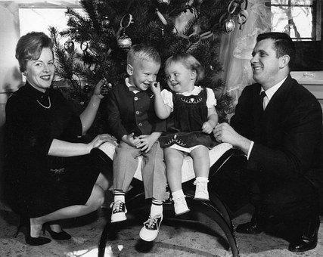
Glossary
common - usual or normal
generation - all the people of about the same age in a family or in society
maternal grandmother - your mother’s mother
paternal grandmother - your father’s mother
in their/ your teens - aged from 13 – 19

Text B
The Rasmussens: A family in the 2020s
Nowadays it is not very common to have big families and this might be because of the cost of bringing up children. Although the Rasmussens are from big families, Alma had six siblings and her husband Gerritt had four, they decided to only have two children. When their son, Erik, was born, Alma went on maternity leave for two years. However, she was keen to get back to work so when her son reached two and a half they started taking him to nursery. When they had their daughter Freja, Alma returned to work after only three months and Gerritt gave up his job to look after the children. Although he liked his job, it was financially better for them as Alma earned a lot more than him. Gerritt did most of the cooking and housework when he was a househusband but when he returned to work the family had a cleaner to clean the house. As the kids got older, the family stopped having a cleaner and the housework and cooking was shared amongst them. The children were given certain chores to do. Erik was responsible for taking out the bins and cleaning the bathroom. Freja did the hoovering and cleaned the floors. Erik did most of the cooking but once a week Alma and Freja cooked something together.

Alma and Freja were very close and whenever Freja needed advice or help with homework, she would go to mum whereas Erik would go to his dad. However, if they wanted permission to stay out late, both kids would need to speak to both mum and dad. Decisions on how to spend the weekend and when to go on holiday were usually discussed by the whole family but usually mum would make the final decision.

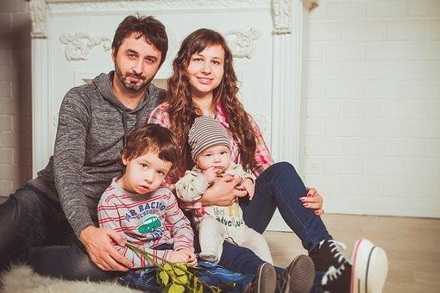

Glossary
common - usual or normal
bring up children - to care for children until they are adults
siblings - your brothers or sisters
(go on) maternity leave - the time a mother gets off work before and after she has a baby
chores - jobs around the house e.g. doing the washing up, making the beds, lay the table etc

