Teachers’ notes
Relationships Marriage B1.2
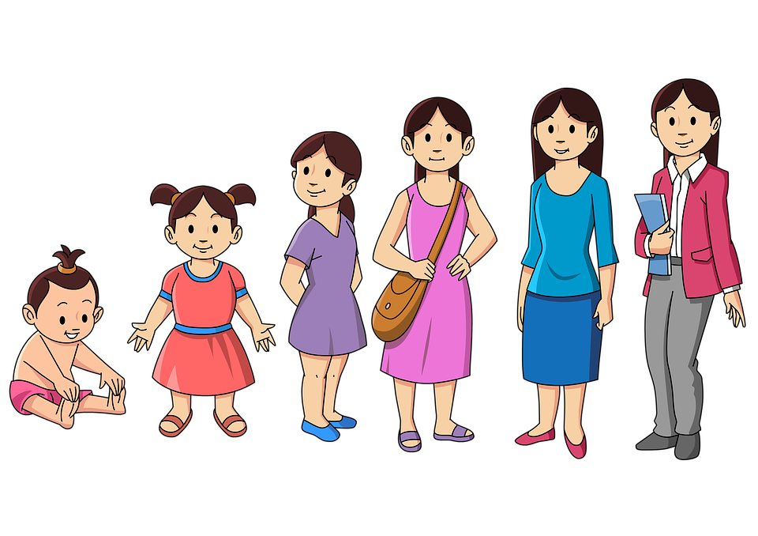
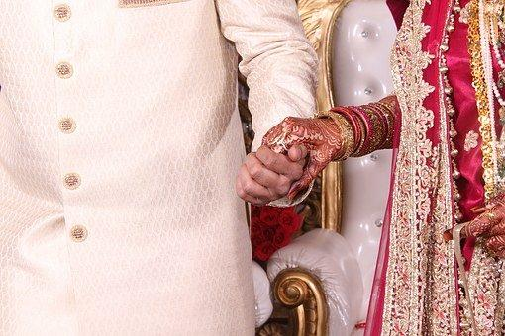
Learning outcomes
By the end of the lesson students will have:
- thought about their feelings about weddings and marriage
- talked about some of the changes in marriages and relationships
- exchanged views on what makes a successful relationship

Materials
Student handout / PPT
All images from www.pixabay.com

Time | Procedure | Materials
5 minutes | - Display and clarify lesson objectives | PPT
10 minutes | - Ask students to look at the pictures in Activity 1 and to think of possible words to describe them e.g. romantic, uncool, expensive, beautiful. Also ask them to think about how they feel about marriage and weddings e.g. ‘I think it’s a waste of money’, ‘I feel very excited about getting married.’ Give them a couple of minutes to work on their own.  - Put them into pairs to compare.  - Conduct whole class feedback to get an idea of their views on marriage. | PPT  Activity 1
15  minutes | - Ask students to discuss the questions in Activity 2.  - Focus on the language in the Language Box before they start the activity and encourage them to use it.  - Conduct whole class feedback and note their ideas on the board. | PPT  Activity 2
10 minutes | - Ask students to complete Activity 3 matching task.  - Ask them to check their answers in pairs and then conduct whole class feedback. Encourage the students to discuss the differences between the country they live in now and their own countries. Do people have arranged marriages? How likely are the people they know or themselves to get married or have religious marriage ceremonies?  [Suggested Answers:  - Why are fewer people getting married nowadays? b), e) and g)  - What are the advantages and disadvantages of arranged marriages? c), f) and i)  - Why are non-religious ceremonies becoming more popular? a), d) and h) | PPT  Activity 3
15  minutes | - Ask students to read the short stories and consider how likely it is that the scenarios could occur in the country they are in now and in other countries they know. Can same sex-couples get married? Is it acceptable for people to live together and have children without being married etc. | PPT  Activity 4
5 minutes | Reflection  - Ask students whether they have learnt about attitudes to marriage in different countries. What changes can they predict regarding marriage in the future in different countries? | Activity 5

Relationships Marriage
Learning Outcome
By the end of the lesson you will have:
- thought about your own feelings about weddings
- talked about some of the changes in marriages and relationships
- exchanged views on what makes a successful relationship

Activity 1: Marriage and you

What words do you think of when you look at the pictures of weddings below? How do the pictures and the idea of marriage make you feel?
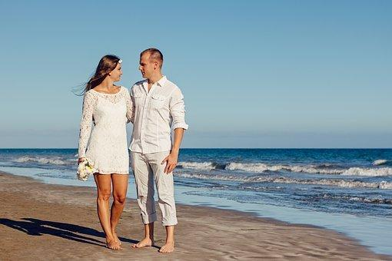
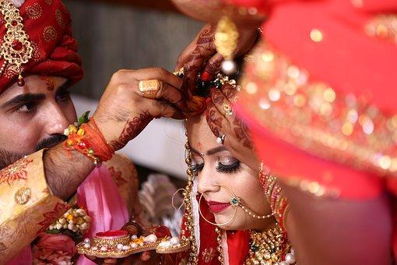
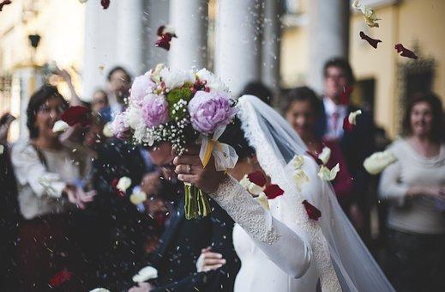
In pairs compare your responses. Do you feel the same way about marriage? If not, do you think this is because of your own personal feelings or your cultural background?
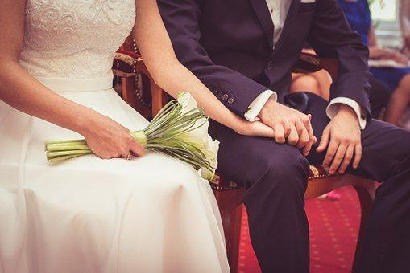
Activity 2: Questions for Discussion
In groups discuss the following questions about marriage.
- Why are fewer people getting married nowadays?
- What are the advantages and disadvantages of arranged marriages?
- Why are non-religious ceremonies becoming more popular?

Language box: Making deductions  When you are quite sure  It must/ can’t / be …  For example: I think, it must be difficult marrying somebody you do not know very well.  For example: It can’t be easy for parents who are very religious see their children have a non-religious ceremony. | When it is a possibility  It might / could / may be …  For example: It might be because people do not think marriage is that important.  Maybe .. /maybe it’s because …  For example: Maybe it’s because they want to choose their own partners.

Activity 3: Maybe it’s because …
Match the ideas below to the questions in Activity 2. How many of the ideas did you think of?

- There are more people of different religions marrying each other.
- People would rather spend their money on other things like buying a house together.
- You sometimes have to pay a matchmaker to find a suitable partner.
- People don’t have connections with religious communities.
- Getting married is an out of date tradition.
- Sometimes people agree to marry someone only to make their parents happy.
- It has become more acceptable to live with someone and not be married.
- The wedding can be more personalised.
- The person you are matched with is someone your family usually likes.
Compare your answers in pairs.

Activity 4: What makes a successful relationship?
a Read the 3 stories below.
How likely are they to happen in the country you live in now?
In another country you have lived in?

Tomislav and Mia
Tomislav and Mia went to school together. They started dating at the age of 13 and when they were 16 they decided to move in with each other. They now have 3 children and have been together for 25 years. Although they have discussed marriage, they have decided not to do it as they are happy with their current situation.

Sten and Johan
Sten and Johan met at work. Sten was 42 at the time and Johan was 26. Sten had
been married before to a woman and that did not work so they got divorced.
The two of them have been together for 15 years and have recently decided to
get married.
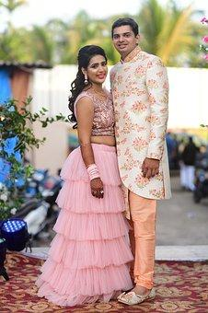
Suresh and Pushpa
Suresh and Pushpa had an arranged marriage. Suresh was 24 at the time and Pushpa was 22. They have 3 children, who are all at school. After 18 years marriage, Suresh told his wife he was unhappy and asked for a divorce. He remarried and is now living happily with his new wife and her children.

b In small groups, discuss which of the statements you agree with.

- Relationships are unlikely to be successful when there is an age difference.
- Couples who meet at a young age do not stay married very long.
- People who get divorced are likely to remarry.
- Families with children are less likely to split up.
When you have been married for over 15 years, you are very likely to stay with your partner forever.

Activity 5: Reflection
What, if anything, have you learnt that is new to you about attitudes to marriage in different countries?
How do you think attitudes to marriage will change in other countries you know in the future?

