Teachers’ notes Level B1.2

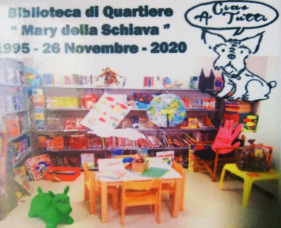
Lesson outcomes
By the end of the lesson students will have:
- understood how to set up a public reading and study area for adults and children.
- read one person’s experience of setting up a community library.
- Discussed how to set up and organise something similar.

Materials
Handout for students
Appendices
PPT
All images taken from Pixabay.com

Time | Procedure | Materials
10 minutes | Activity 1: Discussion about reading.  - Display lesson objectives.  - Ask students if they read? What do they read? What language do they usually read in?  - Do they ever go to a public library?  - What can people do at the library? Choose books, audio books and Dvd’s to borrow, read the newspaper, photocopy and print, learn how to use the computer, how to complete your CV and apply for a job. There are often children’s reading sessions organised by librarians or play leaders and coffee mornings for anyone, especially people who live alone.  - Tell them to discuss these questions in pairs or groups.  - Ask them to summarise their suggestions. | PPT
10  minutes  20 minutes  15  minutes | Activity 2: Read and explain.  - Giorgio is retired and now runs a local library set up in the suburbs of a big town in Italy.  - Ask students to check the glossary for new vocabulary.  - Ask them to look at Appendix 1. The reading is divided into three sections.  - Students work in 3’s. Each member of the group reads one section and prepares to summarise it for the others. After reading they should note key points and then each person explains his section without reading.  - Encourage questions. Make sure they understand everything. Ask about how the library started, about the books, the location, helpers, opening times, legal obligations and other activities.  Activity 3: Setting up a library in your community.  - In their groups tell them to talk about setting up a similar enterprise.  - It must be done with very little or no money.  - Tell them to think about: who can help them, where they can go for advice, the kind of place they could look for, who they could share with if necessary, where they could get bookshelves, tables and computers, where they can go for books of every kind. Are there other events they could organise and not just book-borrowing? Eg. Talks, singsongs and musical evenings?  Activity 4: Discussing ideas together.  - Re-group them so that one person from each group is together. (eg. Give each member of each group a number - 1,2,3 for example – and then put together all number I’s, all number 2’s and all number 3’s.  - Tell them to listen to each other’s ideas and then write one list of ideas per group.  - They then present the lists to the class and evaluate together which ideas are the most practical.  The lists could be posted around the walls for students to read, or read out, one group at a time.
5 minutes | Reflection  - Do students feel enthusiastic about this project?  - How useful can a library be in helping integration?  - Do they think the idea can work where they are living?  - What do they think is their next step to start it up?

Students’ handout

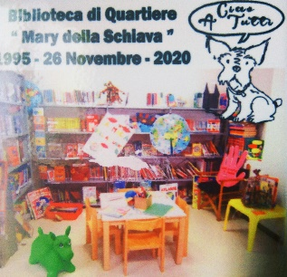
Lesson Outcomes

By the end of the lesson you will have:
- read about setting up a public reading and study area for adults and children.
- read one person’s experience of setting up a community library.
- discussed how to set up and organise something similar.
Activity 1: Discussion about reading.
- Do you read? What do you read? What language do you usually read in?
- Do you ever go to a public library?
- What can people do at the library? Eg. Choose books, audio books and Dvd’s to borrow …. Summarise your suggestions for the teacher.

Activity 2: Read and explain.
- Giorgio is retired and now runs a local library set up in the suburbs of a big town in Italy.
- Look at the glossary at the end of this handout for new vocabulary.
- Now look at Appendix 1. The reading is divided into three sections.
- Work in 3’s. Each member of your group reads one section silently and prepares to summarise it for the others. Make sure you understand everything.
- After reading individually, each of you notes down the key points and then explains them without reading. You can ask questions and the teacher will ask you questions to check your understanding.
Activity 3: Setting up a library in your community.
- In your groups talk about setting up a similar enterprise.
- It must be done with very little or no money.
- Think about: who can help you, where to go for advice, the kind of place you could look for, who you could share with, where you could get bookshelves, tables and computers, where you can go for books of every kind. Are there other events you could organise and not just book-borrowing? Talks, singsongs and musical evenings for example.
Activity 4: Discussing ideas together.
- Re-group so that one person from each group is together.
- Listen to each other’s ideas and then write one list of ideas per group.
- Present them to your teacher and evaluate together which ideas are the most practical.
Reflection
- Do you feel enthusiastic about this project?
- How useful can a library be in helping integration?
- Do you think the idea can work in the area where you are living?
- What do you think is the next step to start it up?

Glossary

- To set up (a club) = to create or establish (a club).
- To run (the club) = to organise and manage (a club).
- To enrol (enrolled) = to join a club, become a member

- To retire/To be retired = to finish working because you are old enough to stop.
- To open on alternate days = to open one day yes, one day no.
- The suburbs of the city = the outskirts of the city, not the centre.

- An aisle = a passage between two rows of seats or (in this case) bookshelves.
- Several = not many, but more than two. Eg. several days = 3 or 4 days, several people = probably between 4 and 10.

Appendix 1
Giorgio’s Library
1)
It all started when a lady living near here, Maria Della Schiava, died and left her large collection of English and Italian books to the town. The local town authorities agreed to set up a library, offered me this room in a quiet area outside the centre and a large hall next to it, for several years without even paying any rent, and advertised for volunteers to run it. Lots of students volunteered and now we have organised a rota, a timetable, so everyone works a few hours a week. In fact the success of the library depends on the volunteers and the support of the local authorities. It is open every afternoon in summer and alternate days in winter.

2)
The room isn’t very wide but it’s long, so we decided to put the librarian’s desk near the entrance and the bookshelves along the length of the room in two lines, so there are three aisles for people to walk along and browse the books. We got the bookshelves from a shop that was closing down, and advertised in the local primary schools for donations of children’s books. The books are all now listed in alphabetical order. The university in town has also donated three of their computers, so we are really, really lucky. I had to ask the dean, the university director, first and then we had to wait at least a year for availability.

3)
Anyone can use the library but if you want to borrow something you must enrol, for free, and children have to get their mother’s or father’s signature, so the parents take responsibility if the boy or girl loses a book for example. The computers are in the big hall and you can book to use one for an hour to do homework or chat online with friends and so on. A man comes in twice a week to help people learn to use the basic computer programmes like Word, Powerpoint and Excel and a psychologist, a very nice, retired teacher, comes along to help people with their CV’s when they ask.

