Teachers’ notes
Communication Being a Good Listener B1.1
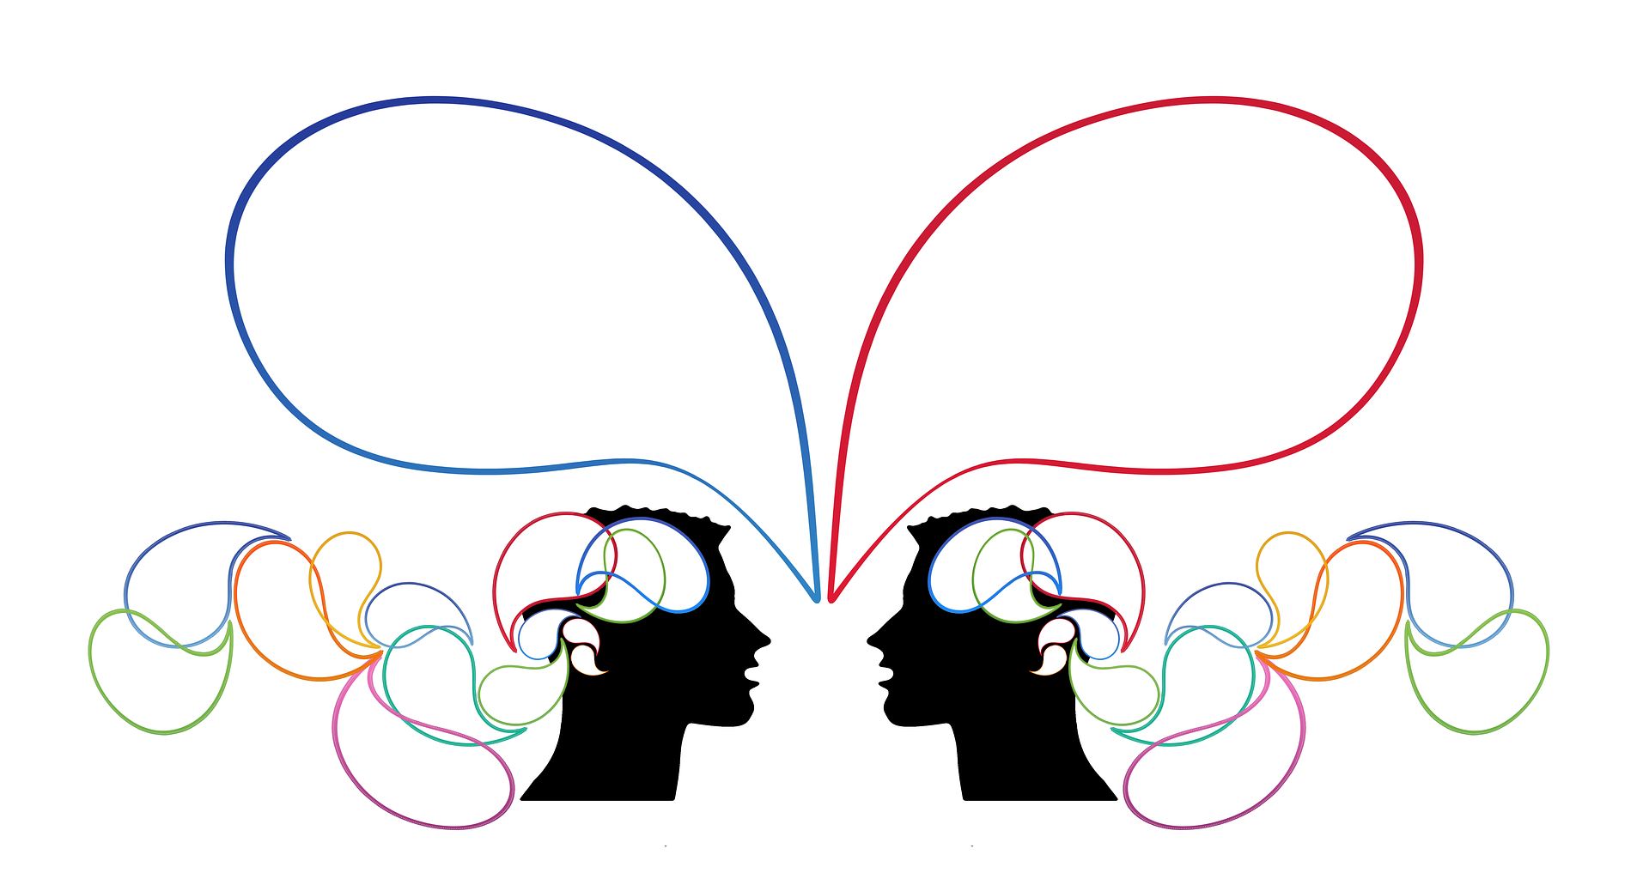
Learning outcomes
By the end of the lesson students will have:
- considered who has and hasn’t listened to them in their lives
- discussed what being a good listener means
- given advice on how to be a good listener

Materials
Handout for students / PPT
Role cards (to be copied and given to students)
Images taken from Pixabay.com

Time | Procedure | Materials
5 minutes | - Display and clarify lesson objectives | PPT
5-10 minutes | Introduction  - Show the pictures on the PPT or ask students to look at the handout. Discuss the following questions in the plenary:  1. What is the relationship between the characters in each picture?  2. Are they good or bad listeners? Why?  - Feedback - focus on body language, eye contact, distractions, reasons for listening, attention spans etc. | PPT  Activity 1
15 minutes | Who has listened to you in your life?  - Ask students to think of an example of one person who has really listened to them in their life and one person who hasn’t. Give your own examples and give learners time to think.  - Put students in pairs to discuss who has/ hasn’t listened to them and why. Allow students enough time to all share their experiences  - Feedback. Ask students to share their views on why they think it’s important to be listened to and how they feel if/ when they aren’t listened to. Discuss factors that may have an impact on how someone listens e.g language skills, interest levels, environment (focus on different countries/ towns students have found themselves in), cultural similarities and differences, relationship between the speaker and the listener and so on.  - Ask students to reflect on whether they think they are good/ not so good listeners themselves and share their views briefly on why they think this. | Activity 2
15 minutes | Good and bad listening  - Divide the group into two – speakers and listeners. Give each group their role cards.  - Ensure speakers cannot hear the instructions you give the listeners – you could give the instructions in different rooms.  - Ensure each group understands the activity and that listeners have ideas for how they can be bad listeners.  - Tell listeners they should listen as attentively and actively as possible for the first minute. Then on your signal (e.g. you saying ‘You have one more minute’), they should become very bad listeners without telling the speaker what they are doing.  - Debrief after the activity – Ask speakers what they noticed and to comment on their partner’s listening skills. How did they feel when their partner’s behaviour changed? Ask listeners how they felt when they were/weren’t listening well.  Discuss the features of good and bad listening that they noticed. | Role cards
10 minutes | Design a poster/leaflet  - Students work in groups to design a poster displaying Do’s and Don’ts for good listening. | Activity 3
10+ minutes | Giving advice on how to be a good listener  - Draw students’ attention to the language box. Elicit ways of giving more tentative advice e.g. I’m not sure but good listeners could, I suppose good listeners could… Encourage students to focus on language they can use before they start giving advice.  - Groups talk through their posters by giving advice about good listening. Each group takes turns to mention one point from their poster. Other groups listen and tick off any points that are also on their posters. Each group can only give advice that has not already been given by another group. (Tell learners this activity requires learners to listen to each other carefully!)  - Conduct whole class feedback. | Activity 4
5 minutes | Reflection  - Students either reflect and make notes individually or discuss what they think with a partner or small group | Activity 5

Communication Being a Good Listener
Learning outcomes
By the end of the lesson you will have:
- considered who has and hasn’t listened to you in your life
- discussed what a good listener does and doesn’t do
- given advice on how to be a good listener
Activity 1: Introduction

Look at the pictures and discuss these questions.
1. What is the relationship between the characters in each picture?
2. Are they good or bad listeners? Why?
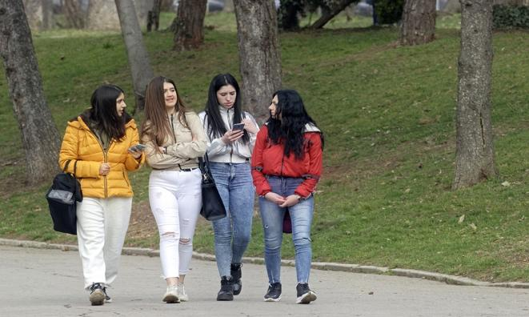 | 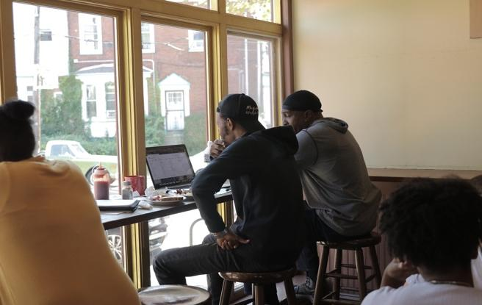

Activity 2: Who has listened to you in your life?

Think of one example of a person who has listened to you in your life and one example of a person who hasn’t. Who were they? What did you talk to them about?

Tell your partner about these two people. Give an example of when they listened or didn’t listen to you. How did you know they were/ weren’t listening to you? Why do you think they listened/ didn’t listen?

Activity 3: Design a poster
Design a poster. Good listening - Do’s and Don’ts.

Do’s
Don’ts

Activity 4: Giving advice on how to be a good listener
Look at the language box below. Can you add other ways of giving advice and expressing opinions?

Language Box: Giving advice
I think good listeners should ...
e.g. I think good listeners should use body language to show that they are listening
I don’t think good listeners should...
e.g. I don’t think good listeners should look away when someone is talking

Share the advice on your posters with other groups. Use the language in the box to help you.

Activity 5- Reflection
How easy do you find it to listen to other people? Do you find it easier to listen to
some people more than others? Why do you think this is?
Do you think language and culture influences the way people listen to each other?

Appendix 1: Role cards

Listener
You are going to listen to your partner talking about what they did last week. Start by being a very GOOD listener – the best listener you can be. After your teacher says, ‘you have 1 more minute’, become a very BAD listener – start by being quite bad and then become the worst listener you can be! Don’t tell your partner what these instructions are.

Speaker
You are going to speak to a partner. Tell your partner what you did last week. You will need to talk for at least two minutes, so prepare to talk about what you did every day, every evening and at the weekend. Give as much detail as possible.

