Teachers’ notes
Communication Values and Beliefs B1.2
Learning outcomes
By the end of the lesson students will have:
- shared and discussed their personal values and beliefs
- watched a short YouTube clip on values
- produced written responses to questions on values and beliefs
- considered how values and beliefs can help them be a part of the society they live in

Materials
Student’s handout / PPT
https://www.youtube.com/watch?v=Lg-wNxJ5XxY
All images taken from Pixabay.com

Time | Procedure | Materials
5 mins | - Display and clarify lesson objectives | PPT
10-15  minutes | - Tell students you want them to think about what is important to them right now in their lives. Consider brainstorming some examples as a class.  - Share three things that are important to you and comment on how difficult you found it to think of only three things. Use one of the phrases in the language box when you do this.  - Tell students to work on their own and think of three things that matter to them. Monitor and offer support as necessary  - Before placing students in groups go through the language items in the box and encourage them to use some of the phrases when they share their choices with their partner.  - Place students in pairs or breakout rooms and allow them time to explain their choices.  - Briefly conduct whole class feedback. | Activity 1  PPT
15 minutes | - Tell students they are going to watch a short YouTube video, “What matters the most in life”. Before playing the clip allow students time to read through the questions and deal with language queries they may have. https://www.youtube.com/watch?v=Lg-wNxJ5XxY  - If students are not familiar with the difference between not given and false explain that not given means the speaker doesn’t mention this at all in the video and false contradicts what the speaker says.  - Play the video clip and then allow students to compare their answers together and to respond to what the content of the clip.  - Conduct whole class feedback and go through the answers together. [Answers 1. F 2. NG 3. NG 4. F 5. T 6.T 7. F 8. T 9. F 10. NG] | Activity 2  YouTube Clip  PPT
15 -20 minutes | - Tell students they are going to have to produce written responses to three questions about values and beliefs.  - Go through each question and deal with any unfamiliar words.  - Allow students time to think and formulate their written responses to each question. Depending on the level of the group you may want to encourage stronger students to write their notes in full. Those who struggle with writing may wish just to write key words in their responses. Monitor and offer support as necessary  - Place students in small groups and ask them to share and discuss their responses.  - Conduct whole class feedback and invite students to discuss as a class how people with different values and beliefs can and do live together | PPT  Activity 3
5-10 minutes | - Conduct a plenary and ask students to share their thoughts and understanding on EU values. Go through each to check students understand what they cover or display the following:  https://ec.europa.eu/component-library/eu/about/eu-values/  https://www.totalpeople.co.uk/about/british-values/#:~:text=These%20values%20are%20Democracy%2C%20Rule,Democracy  - Reinforce the key values of the EU/ UK and point out by understanding these they are likely to find integrating into society easier. | PPT  Activity 5

Students’ handout
Communication Values and Beliefs
Learning Outcomes
By the end of the session, you will have:
- shared and discussed personal values and beliefs
- watched a short YouTube clip on values
- produced written responses to questions on values and beliefs
- considered how values and beliefs can help them be a part of the society they live in

Activity 1: What Matters to Me.
Think about your life. Think about where you live and what you do. Write down three things that are really important to you right now.

1.__________________________ 2. ______________________ 3. _______________________
It can be difficult to think of only three things that are important to you. Use the language in the box below to explain your choices to your partner.

Language Box: Saying Something Was Difficult
This wasn’t the easiest thing to do but ...  I found it ever so tricky to...  It was really tough choosing only three things but, in the end, I went for... | To be honest I really struggled to think of...  I struggled a bit with this but my final top three are...

Activity 2: What Matters Most in Life?
As you watch the video clip decide if the following statements are True (T), Talse (F) or Not Given (NG).

1.Money is definitely something that makes people happy in life.
2. Whilst love is good for you, it’s not as important as happiness.
3. People who are generally unhappy find it difficult to love others.
4. How someone feels is equally as important as their personal values.
5. Values can stop you from following your feelings.
6. There can be a lot of tension between how you feel and your values.
7. An animal’s life is just as precious as a human’s life.
8. A person who has high moral values is less likely to cheat.
9. Criminals have no values whatsoever.
10. Only law-abiding citizens struggle with their feelings and values on a daily basis.
Compare your answers with your partner
What do you think of what Dennis Prager had to say about our values and feelings? To what extent do you agree with him?
What or who can influence our values and feelings?
Activity 3: What Do You think?
Read through the questions below and make some notes below each question.

1.Look at the list of common core values below. Do you think these values are as important to people where you live now compared to where you lived before?

Faith Family Freedom Friendship Health Happiness
Honesty
Respect Tradition Trust Wealth

2.How important do you think it is to understand the values and beliefs of the people in the country where you live now? Why do you think this?

3.How realistic do you think it is for people with different values and beliefs to live together?

Discuss your responses to each question with your group

Activity 4: Reflection
Talk about the following EU values and how important they are where you live now and how they could help you integrate into your local community.

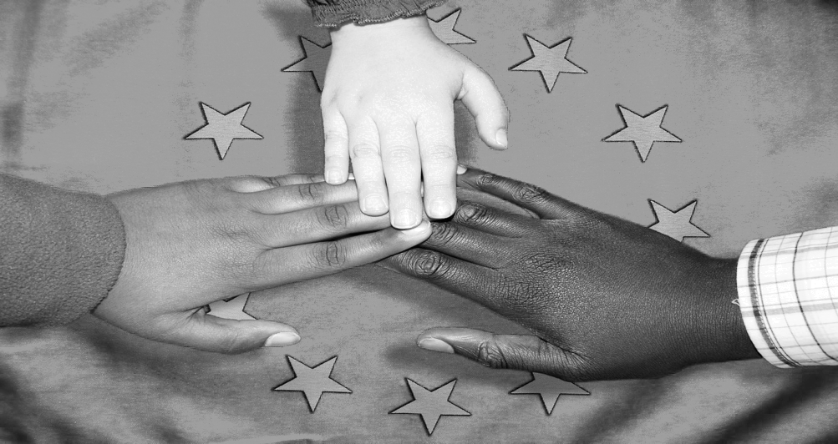
Democracy
Equality (same rights for all regardless of gender)
Freedom (of thought, speech and movement
The Rule of Law
Human Dignity (respect and protect fundamental rights)
Human Rights (free from discrimination)

