Teachers’ notes
Communication Active Listening B1.1
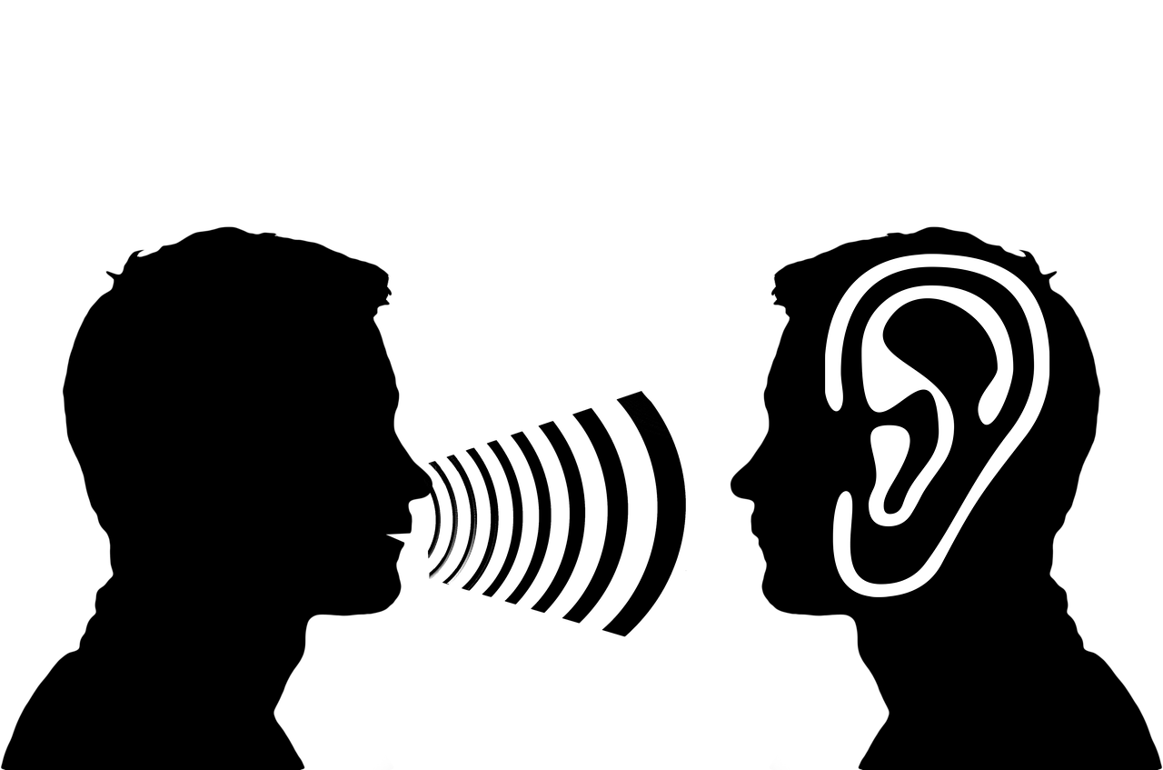
Learning outcomes
By the end of the lesson students will have:
- considered what active listening is and why it is important
- learned how to make suggestions to help others improve their active listening skills
- practised active listening

Materials
Learner’s handout/ PPT
https://www.skillpacks.com/chinese-character-listening-5day-plan/ (for image of Chinese character for listening)
https://www.youtube.com/watch?v=t2z9mdX1j4A
Images from www.pixabay.com

Time | Procedure | Materials
5 minutes | - Display and clarify lesson objectives | PPT
10 minutes | Introduction  - Tell the students 2 short stories; one where you told someone something and they clearly listened and another where you had a conversation with someone and they clearly weren’t listening. If you can’t think of any stories, make them up. Ask students to think of 2 examples of their own when someone really listened to them and when someone didn’t. This could be in their new country or their own country. Suggest that it could be a family member, friend, teacher etc.  - Give students time to think and prepare individually then put them into pairs to tell each other their experiences.  - Conduct whole class feedback. Discuss these questions:  - How do you feel if you aren’t listened to?  - Why is listening to other people important?  - How do you know when somebody is or isn’t listening? | Activity 1
10 minutes | What is active listening?  - Ask students to look at the Chinese character for the verb to listen on the screen or on the handout. Tell them it is a good depiction of active listening. Ask students why Ears, Eyes, Heart, Mind and Undivided attention are important for being a good, active listener.  Suggested answers:  [Ears – to hear the message. Eyes – to notice non-verbal aspects of communication. Heart – to try and understand the feelings and emotions of the speaker, not just the words they say. Mind – to engage with the speaker’s message. Undivided attention – to focus on what the speaker is saying without judging or forming/giving your own opinions first]. | Activity 2
15 minutes | Vocabulary  - Check understanding of the vocab in the activity which is noted in the glossary box i.e., ‘put your thoughts on hold,’ ‘interrupt’ and ‘body language.’  - Put students into groups of 3 or 4 to decide which of the expressions describe good or bad listening habits. Encourage students to share ideas and guess if they aren’t sure. Conduct whole class feedback. Also ask students to think about which points relate to the different aspects of active listening.  Suggested answers:  ✓ pay close attention to everything the speaker is saying  ✓ make eye contact throughout the conversation  X only focus on what the speaker is saying and nothing else about them e.g. body language  ✓ put your thoughts on hold  X interrupt to check information  X plan how you are going to respond at the same time as listening  start to talk about your own experiences  ✓ show that you are listening by smiling, nodding or saying ‘Yes’  ✓ repeat back to the person what they said to you to check that you have understood correctly  ✓ ask questions to get more information  X decide on your own opinions before the speaker has finished speaking  X think about something else at the same time as listening | Activity 3
5 minutes | Listening  - Watch the video clip from 47 seconds in.  Tell students to underline the points in Activity 3 that are mentioned. Tell them to check their answers in pairs then conduct whole class feedback. Encourage students to add more ideas if they can.  Possible answers:  - pay close attention to everything the speaker is saying  - make eye contact throughout the conversation  - only focus on what the speaker is saying and nothing else about them e.g. body language  - put your thoughts on hold  - interrupt to check information  - plan how you are going to respond at the same time as listening  - start to talk about your own experiences  - show that you are listening by smiling, nodding or saying ‘Yes’  - repeat back to the person what they said to you to check that you have understood correctly  - ask questions to get more information  - decide on your own opinions before the speaker has finished speaking  - think about something else at the same time as listening  - finish the speaker’s sentences for them | Activity 4
10 minutes | Practise active listening  - Give students time to prepare one of the suggested topics. Tell them they will need to talk about it for approximately 2 minutes. Before they start the activity, draw their attention to the language box focusing on the language of making suggestions and criticising.  - Explain that the speaker will give their partner feedback on their active listening skills after they have talked about their topic.  - Put students into pairs to practise active listening for two minutes and then tell them to give each other feedback using the expressions in Activity 3 and the language in the box. | Activity 5
5 minutes | Reflection  - Encourage students to consider how different/similar listening and speaking conventions are in their new country and country of origin if they have lived in other countries.  - Finish by establishing which aspects of active listening they could work on and improve and how conversations differ or are the same in their new country (for those living in a new country). | Activity 6

Communication Active Listening
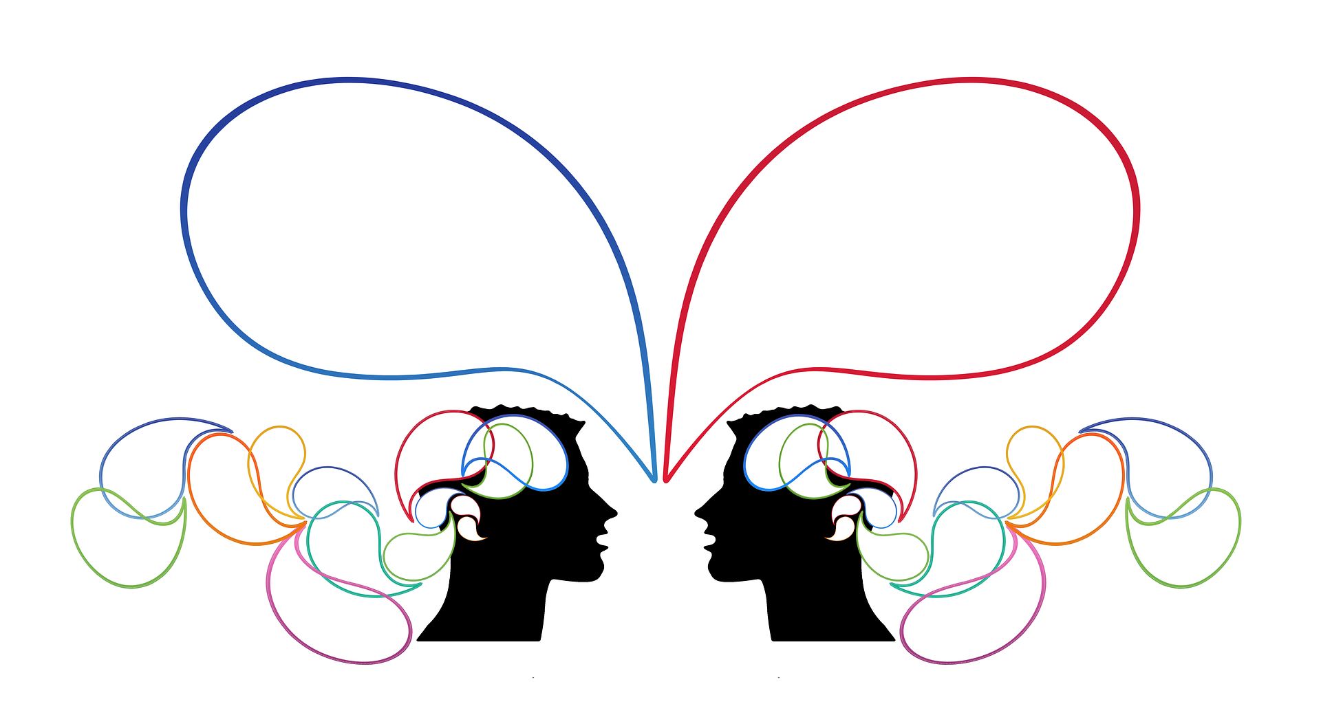
Learning Outcomes
By the end of the lesson you will have:
- considered what active listening is and why it is important
- learned how to make suggestions to help others improve their active listening skills
- practised active listening

Activity 1: Good and bad listening
Think of an example of one person who you feel listened to you in your life and an example of one person you feel did not. Who were they? What did you talk to them about?

Tell your partner about your experiences with these two people. How did you know that they were or were not listening to you?

Activity 2: Active listening
This is the Chinese character for the verb to listen. It is made up of different parts that together describe active listening.

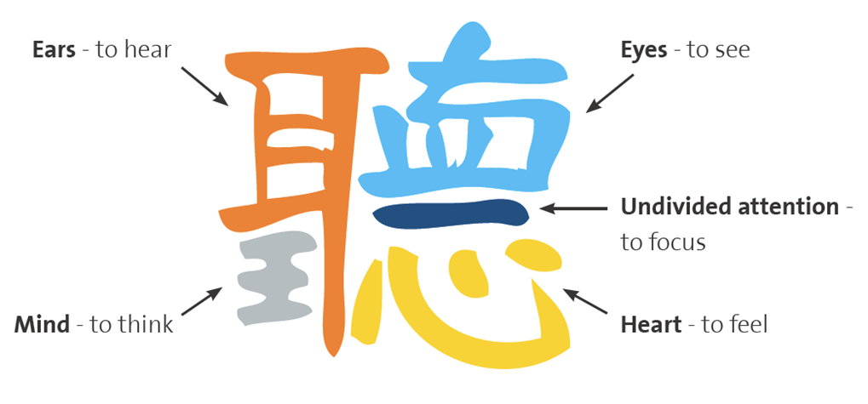

Why do you think ears, eyes, mind, heart and undivided attention are important for active listening?

Activity 3: Good and bad listening habits
Decide if these actions describe good ( ✓ ) or bad listening habits ( X ).

pay close attention to everything the speaker is saying
make eye contact throughout the conversation
only focus on what the speaker is saying and nothing else about them e.g. body language
put your thoughts on hold
interrupt to check information
plan how you are going to respond at the same time as listening
start to talk about your own experiences
show that you are listening by smiling, nodding or saying ‘Yes’
repeat back to the person what they said to you to check that you have understood correctly
ask a lot of questions
decide on your own opinions before the speaker has finished speaking
think about something else at the same time as listening
finish the speaker’s sentences for them

Glossary
to put your thoughts on hold (v) - to remember an idea of thought that you just had to use later
to interrupt (v) - to stop somebody when they are in the middle of speaking or doing something by something you say or do
body language (n) - use of part of your body e.g. your eyes, hands, mouth etc to show other people how you are feeling without using words

Activity 4: Active Listening
Watch the video clip about active listening

As you are watching the video, underline the points that the presenter talks about.

Discuss which words and expressions relate to Ears, Eyes, Heart, Mind and Undivided attention?

Can you add any more ideas?

Activity 5: Active listening in action
Prepare to talk about one of these topics:
- What you did last weekend
- Your hobbies
- Your best friend
- Your family
- A journey you have taken

Practise active listening following the suggestions for good active listening in Exercise 3.

Use the language in the box to give your partner feedback on their active listening skills.

Language Box:  Making suggestions  You could ……….  e.g. You could use your hands more  Why don’t you + bare inf. ……?  e.g. Why don’t you ask a few more questions?  How about + -ing?  e.g. How about waiting longer before you speak? | Criticising  You shouldn’t + bare inf.  e.g. You shouldn’t interrupt unless you are sure I have finished speaking

Activity 6: Reflection
What difficulties do you have listening to people or do you feel you listen well to other people?
Which aspects of active listening do you think you could work on and improve?
If you have lived in a different country, how similar or different is the way people speak here compared to that country?
Active listening is harder than you might think. Keep practising!

