Teachers’ notes
Work Choosing a Volunteering Role B1.3
Learning outcomes
By the end of the lesson students will have:
- thought about the advantages of different volunteering roles for different people
- read and discussed different volunteering roles
- written about what is important to them in a volunteering role

Materials
Student handout / PPT
Appendix 1 roles adapted from https://www.volunteerworld.com/en
All images taken from www.pixabay.com

Time | Procedure | Materials
5 minutes | - Display and clarify lesson objectives. | PPT
15  minutes | - If this is the first lesson on volunteering you have done with the class, ask students to think of different volunteering roles they might be aware of in addition to who might benefit from volunteering organisations. Also ask then to consider what benefits there are for volunteers. If you have done the other lessons ask who they believe benefits from volunteering.  Focus on the fact that it’s both the people who have things done for them and the people doing the volunteering.  - Tell students they are going to look at an advert for an organisation called ReCycle and should answer the questions. One question focuses on the hard and soft skills that a volunteer might develop. Definitions of hard and soft skills are given in addition to some examples of soft skills; focus on these to check understanding. Conduct whole class feedback.  [Suggested answers:  benefits to local community – people get bikes so save money on transport, get fit, learn how to repair bikes  hard skills = bicycle repair, how to train people, how to organise an event, how to fundraise (could also be a soft skill)  soft skills = customer service, problem solving, training people, working with different types of people, working in a team, organisation of events, Customer service and training could be in both hard and soft skills: there are aspects of customer service which can be taught but at the same time, good customer service also involves ‘people skills] | PPT  Activity 1
20 minutes | - Put students into groups and give them the cards with information about different volunteering roles. In a face-to-face classroom, you could cut the cards up and suggest that they have them turned down on the table. Suggest that they turn them up one by one and discuss who might be helped and how they might be helped. They should then think about the role from a volunteering point of view and think about what hard and soft skills a volunteer could develop from doing the role. Conduct whole class feedback at the end of the discussion. | PPT  Activity 2
15  minutes | - Introduce Nesreem and tell students that she has decided she is interested in one of the roles and would like to apply. Ask her to look at an extract from her application and decide which role she is interested in.  [Answer: Farming and gardening conservation support]  - Tell students they are going to write a paragraph applying for one of the roles. Suggest that before they start writing they should make some notes and think about the reasons they are interested in a particular role. Focus students’ attention on the language she uses from the language box and encourage them to use it in their own paragraph.  - If time is short, do the preparation in class and ask students to do the writing for homework. | PPT  Activity 3  a & b
5 minutes | - Conduct a plenary and ask students to reflect on how they can/are developing their own soft skills. | PPT  Activity 4

Work Choosing a Volunteering Role
Learning outcomes
By the end of the lesson, you will have:
- thought about the advantages of different volunteering roles for different people
- read and discussed different volunteering roles
- written about what is important for you in a volunteering role

Activity 1: Volunteers wanted
Look at the advert for ReCycle and answer the questions.
How does the charity benefit people in the local community?
What hard and soft skills could a volunteer develop from volunteering for this charity?
Hard skills are the skills or knowledge you learn through education, training or work experience and are specific to particular roles.
Soft skills are people or social skills that can be used in any role. Examples include working in a team, relationship building, time management, events organisation, customer service, communication skills, working with different types of people, leadership, following instructions etc.

ReCycle Needs Your Help
We need your old bikes
We take any bikes you don’t want and repair them to give to anyone who is unable to buy a bike for themselves. We then give them free cycling and bicycle repair training
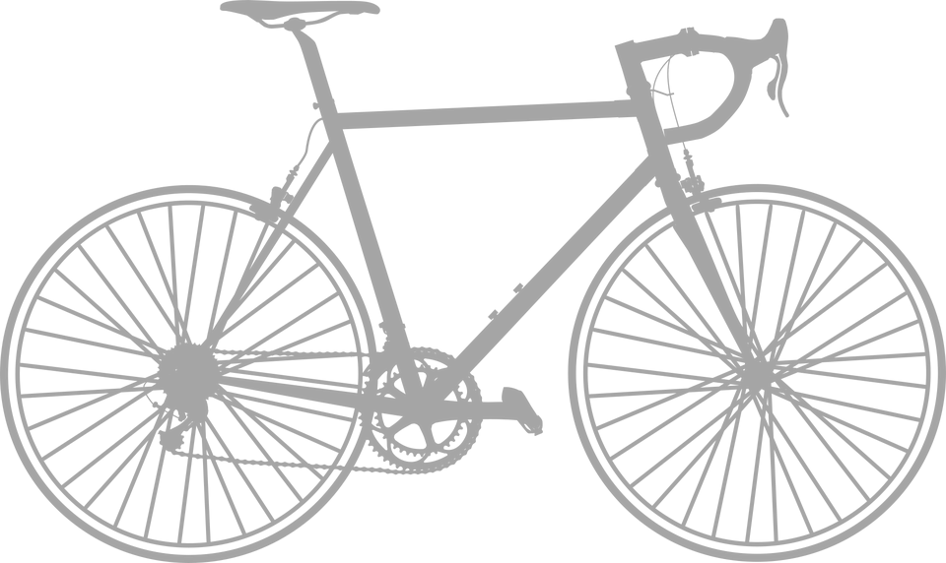
We need volunteers to
- repair the old bikes
- train beginner cyclists
- train people to do their own repairs
- organise fund-raising events
- collect and deliver bikes

Activity 2: Volunteering roles
Look at the set of cards your teacher has given you. Read and discuss the benefits of each of the volunteering positions. Think about:
- who might be helped by the project and how they are helped
- what soft and hard skills could be learnt whilst volunteering

Activity 3: Choosing a volunteering role
a Nesreen has been reading about the different volunteering options would like to apply for one of the roles. Look at an extract from her application. Which role is she interested in?

I believe doing this this role would help me to get a job that I would like in the future. The role interests me because, I want to work outdoors. I’m worried about climate change and I want to learn more about ways of protecting our planet. I’ve done some gardening in the past but I’d like to get better at it. I think I need to develop other skills too so working in a shop would give me a different type of work experience. On balance, I’d prefer to work in the countryside rather than in a town or city.

b Use the language in the language box to write a paragraph applying for one of the roles.

__________________________________________________________________________
_____________________________________________________________________________
_____________________________________________________________________________
_____________________________________________________________________________
_____________________________________________________________________________
_____________________________________________________________________________
_____________________________________________________________________________
_____________________________________________________________________________
_____________________________________________________________________________
_____________________________________________________________________________
Language Box: Talking about future interests, intentions and preferences
Doing this role would help me to … I’d like to get better at XXX so …
This role interests me because … I think I need to …
I want to learn more about XXX On balance, I’d prefer to XXX rather than YYY

Activity 4: Reflection
To what extent should people be encouraged to do voluntary work from a very young age?
As far as you are aware, do employers in countries you know, accept volunteering as valid work experience?
What do people you know such as older family members and friends think of volunteering? Do they think it is a good idea?

Appendix 1

Food Rescue Helper
Work in a team to feed over 3000 people a day from our base in Lisbon. We collect excess food from restaurants, cafes and supermarkets around the city, We organise it into food packages and finally distribute it amongst the elderly and homeless.
excess = a lot extra. too much
distribute = to give to several people
Supporter for Children’s Education
Help children from disadvantaged backgrounds to achieve success and prepare them for a brighter future. Tutor them in after school programmes, help them with their homework, organise sports events, play games and create art projects.
disadvantaged backgrounds = without the standard of living conditions or education that most people have
Farming and Gardening Conservation Support
Help us to protect our countryside using a range of farming and gardening methods that support the natural environment. You can also take part in our woodlands projects protecting native trees, bat houses and beehives as part of a conservation scheme. Volunteers will also work in our Farm Shop and Cafe selling and serving food products from local farms.
conservation = the protection of plants, animals, natural areas and buildings from the negative effects of human activity
native = plants and animals that grow naturally in a particular area
Helping People with Special Needs
This project involves supporting people with physical and mental needs living in supported living, to live independent lives. There are a range of tasks you can help with such as accompanying them to visit friends and family, going on shopping trips, developing everyday living skills such as cooking and cleaning, supporting personal care and / or assisting with an entertainment programme.

personal care = cleaning, dressing etc of people who are unable to do it for themselves because they are disabled or elderly

