Teachers’ notes
Relationships Family B1.2
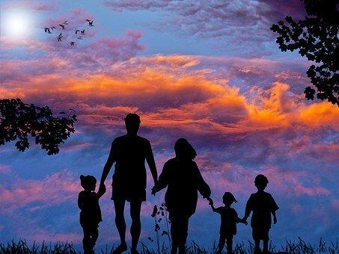
Learning outcomes
By the end of the lesson students will have:
- become familiar with key words to describe different families and family
members
- described a family and listened to a description of a family
- compared and contrasted different family set ups

Materials
Student handout / PPT
All images from www.pixabay.com
Photos of different families in Appendix 1. These can be supplemented as necessary.
Appendix 2- transcript of recording (Maya’s family- old and new)

Time | Procedure | Materials
5 minutes | - Display and clarify lesson objectives | PPT
10-15  minutes | - Place students in pairs/ threes and explain that they each have a different picture of a family and they need to describe their family to their partner/ group. Those listening can either draw what they hear or make a note of the key words. Set a time limit to ensure descriptions don’t go on too long.  - Once students have finished describing their pictures, display each picture (slide 4 contains all photos) and find out who made a note or drew that particular picture.  - Elicit key words connected to the pictures - nuclear family, extended family, foster family, in-laws, stepmother/father, half-brother/ sister. Check meaning and focus on pronunciation.  - Establish that families come in different shapes and sizes. | Pictures (see Appendix 1)  PPT  Activity 1
10-15 minutes | - Tell students they are going to listen to a recording of a student describing their family. Set the task. Explain that they have to tick the words they hear the speaker using in their description.  - Play the recording. If the recording is not available, read it yourself from the tapescript.  - Allow students to compare their answers in pairs prior to conducting whole class feedback. [aunts, uncles, cousin, mum, dad extended family, only child, foster, nuclear, step-mum/dad]  - Explain that students are going to listen to the recording again but this time they have to decide whether the answers in task 2 are true or false.  [Answers:  - Maya has a twin brother. F she is an only child  - Not many families live together like Maya did with her family in her country. F it is common to live with your extended family members  - Maya was a lonely child. NG she was an only child, but we don’t know if she was lonely.  - Maya has always lived with the same foster family. F she has lived with two.  - Maya wishes she lived in an extended family.NG  - Maya doesn’t call her foster parents by their first names. She calls them mum and dad. T.]  - Play the recording, allow students to compare their answers and then review answers during whole class feedback. Encourage students to respond to the follow up questions about their thoughts on Maya’s families and her views of different families. | PPT  Activity 2
20 minutes | - Explain that students are going to write a description of a family. This can be their family, a family they know or a made-up family.  - Elicit what to include in a description. Refer back to Maya’s description and the points in Activity 3.  - Encourage students to think and plan their work before writing their descriptions.  - Monitor as appropriate.  - Allow students 10-15 minutes to write their descriptions.  - Depending on time the descriptions can be displayed around the room and students can read them and think of questions they would like to ask each other. Alternatively place students in small groups and ask them to share their descriptions and ask each other questions. | Activity 3
5 minutes | Plenary  - Conduct a plenary and ask students to reflect on and share their views on different types of families - traditional and modern and to think about how families are viewed where they live now and if relevant where they have lived in the past. | Activity 4

Relationships Family
Learning outcomes
By the end of the lesson you will have:
- looked at words to describe different families
- described a family and listened to a description of a family
- compared and contrasted different families

Activity 1: Families

Look at the picture you have of a family. You are going to describe the picture to your group.
Your group will draw or make notes of the family you describe. You will do the same when you listen to their descriptions. Your teacher will give you some paper to write or draw on.

Activity 2: My family - old and new.
2.1 Listen to Maya talk about her family. As you listen, tick ✓ the words you hear.

A nuclear family  An extended family  A foster family  An adopted family  An only child  A twin |  | Mother  Step mum  Sister  Half-sister  Aunt  Single parent  Parent |  | Cousins  Father  Uncle  Stepdad  Brother
Compare your answers with your partner.

2.2 Listen to Maya again and decide if the statements are true or false or not given.

- Maya has a twin brother.
- Not many families live together like Maya did with her family in her country.
- Maya was a lonely child.
- Maya has always lived with the same foster family.
- Maya wishes she lived in an extended family.
- Maya doesn’t want to call her foster parents mum and dad.
Compare your answers with your partner.

What do you think of Maya’s story and her views on different families? How common do you think Maya’s story is where you live?

Activity 3: My family or a family I know.
You are going to write a description of your family now, your family in the past or a family you know.

Look at what you can include in your description and make some notes below.

- type of family ___________________________________________________________________

_______________________________________________________________________________

- different members of the family and their names_______________________________________

_______________________________________________________________________________

- feelings about the family___________________________________________________________

_______________________________________________________________________________

- relationships in the family_________________________________________________________

_______________________________________________________________________________

Write your descriptions.

Activity 4: Reflection on different types of families
Think about the different families you know.
Discuss what you think of different types of families. Do you think that some families are better than others? Why? Why not?

Appendix 1: Photos of families

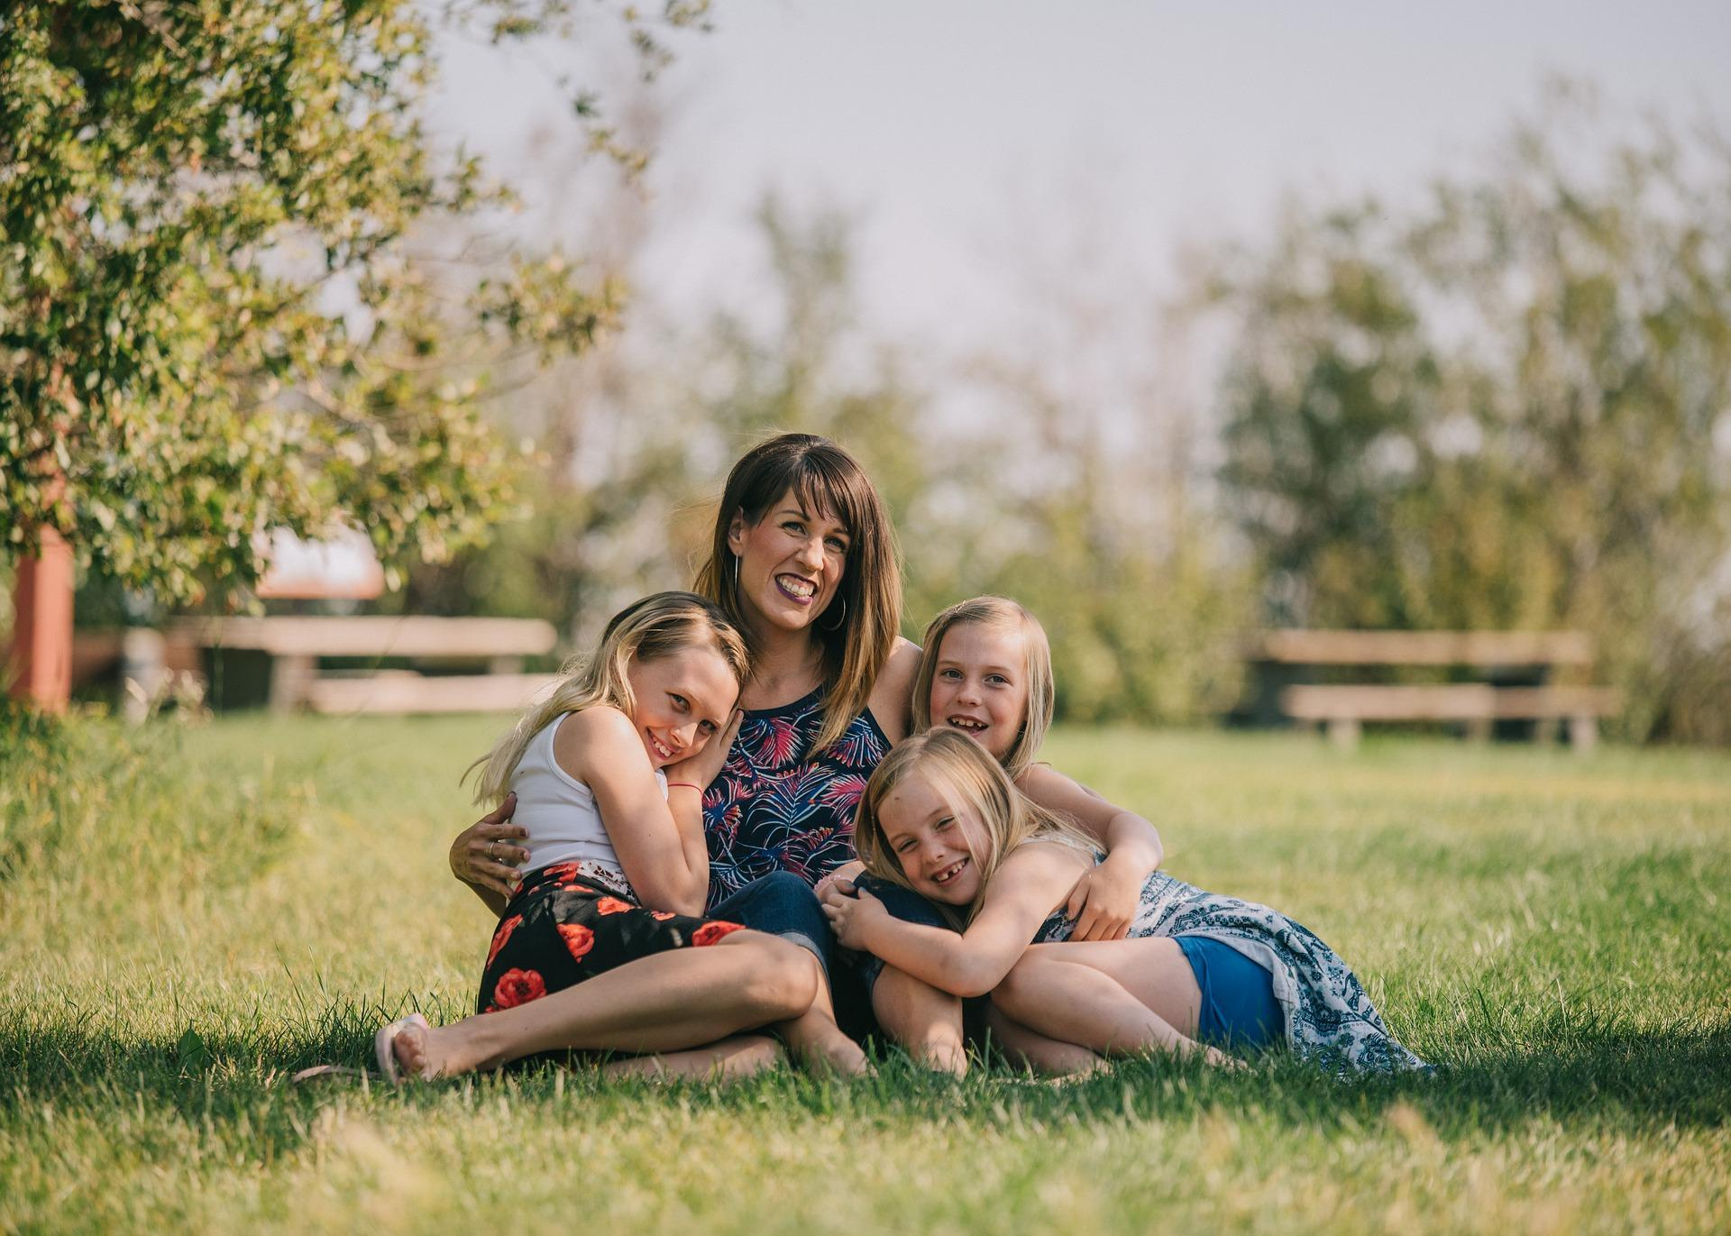  Picture A | 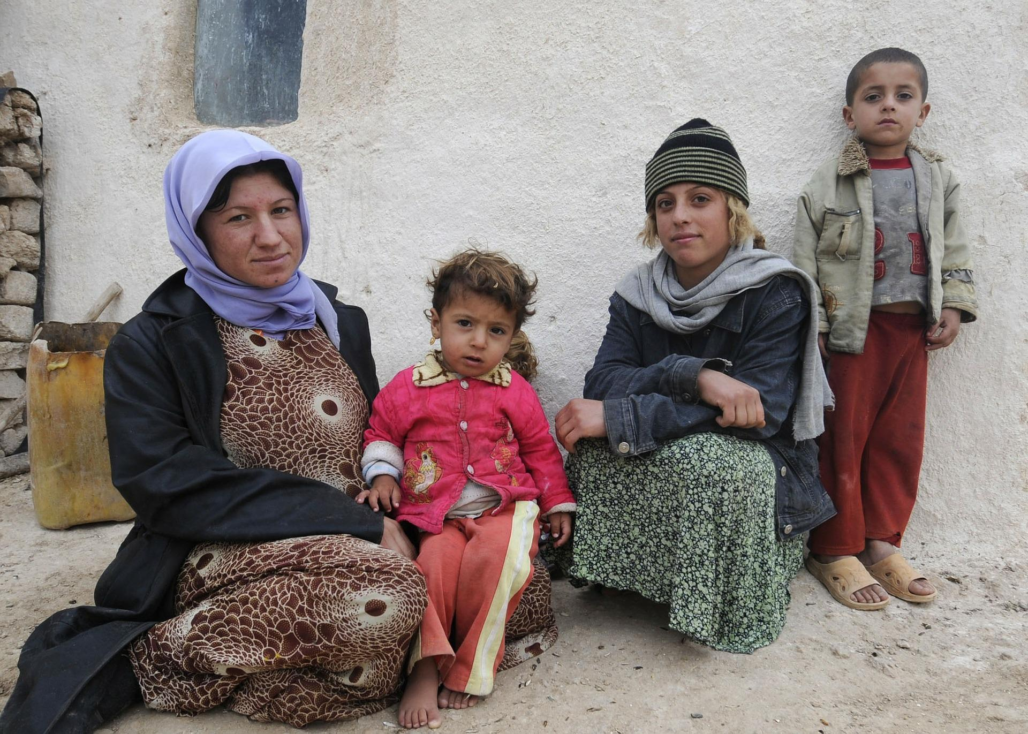  Picture B
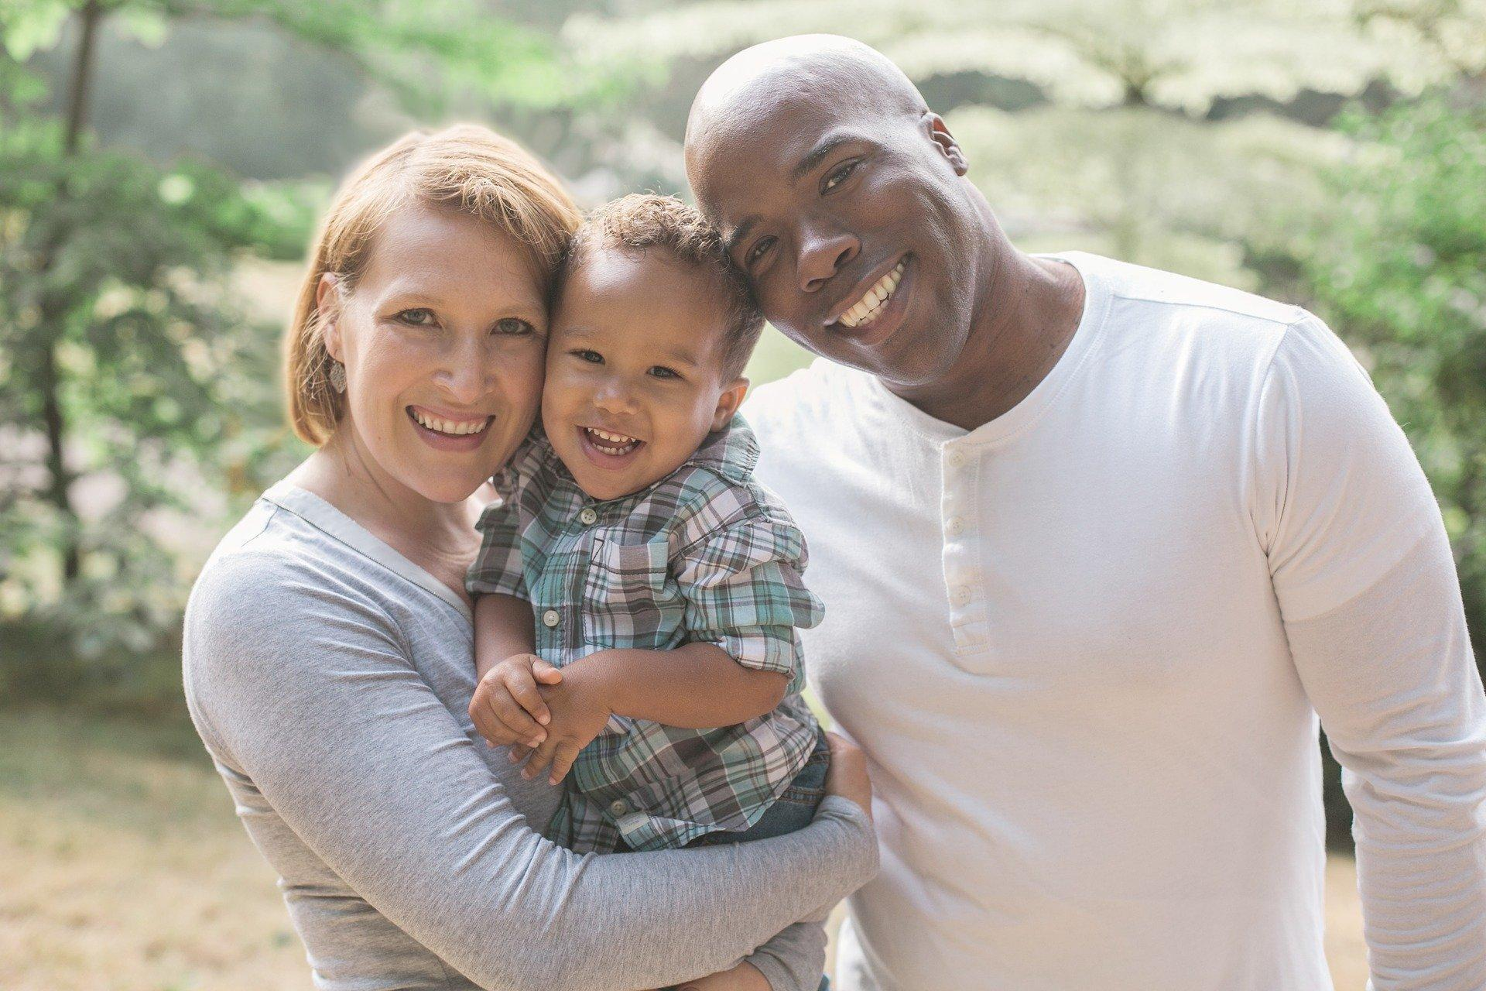  Picture C | Picture D

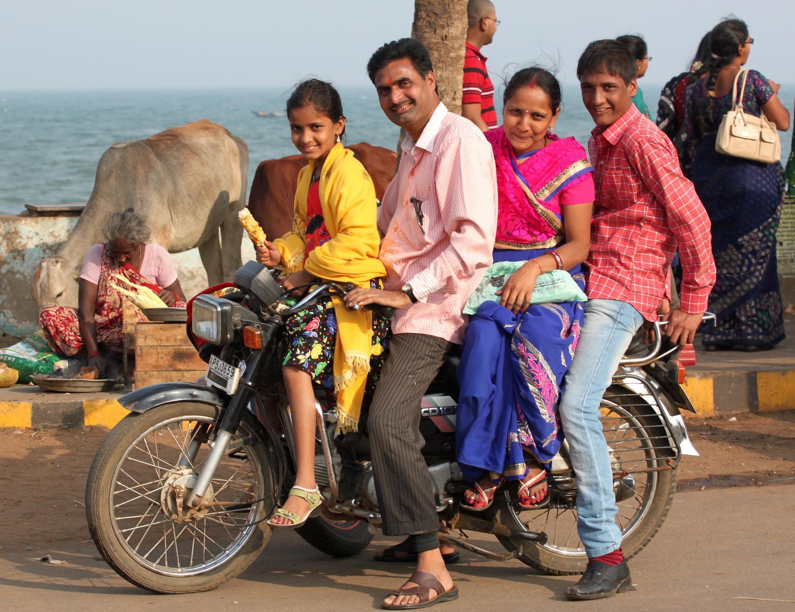  Picture E | 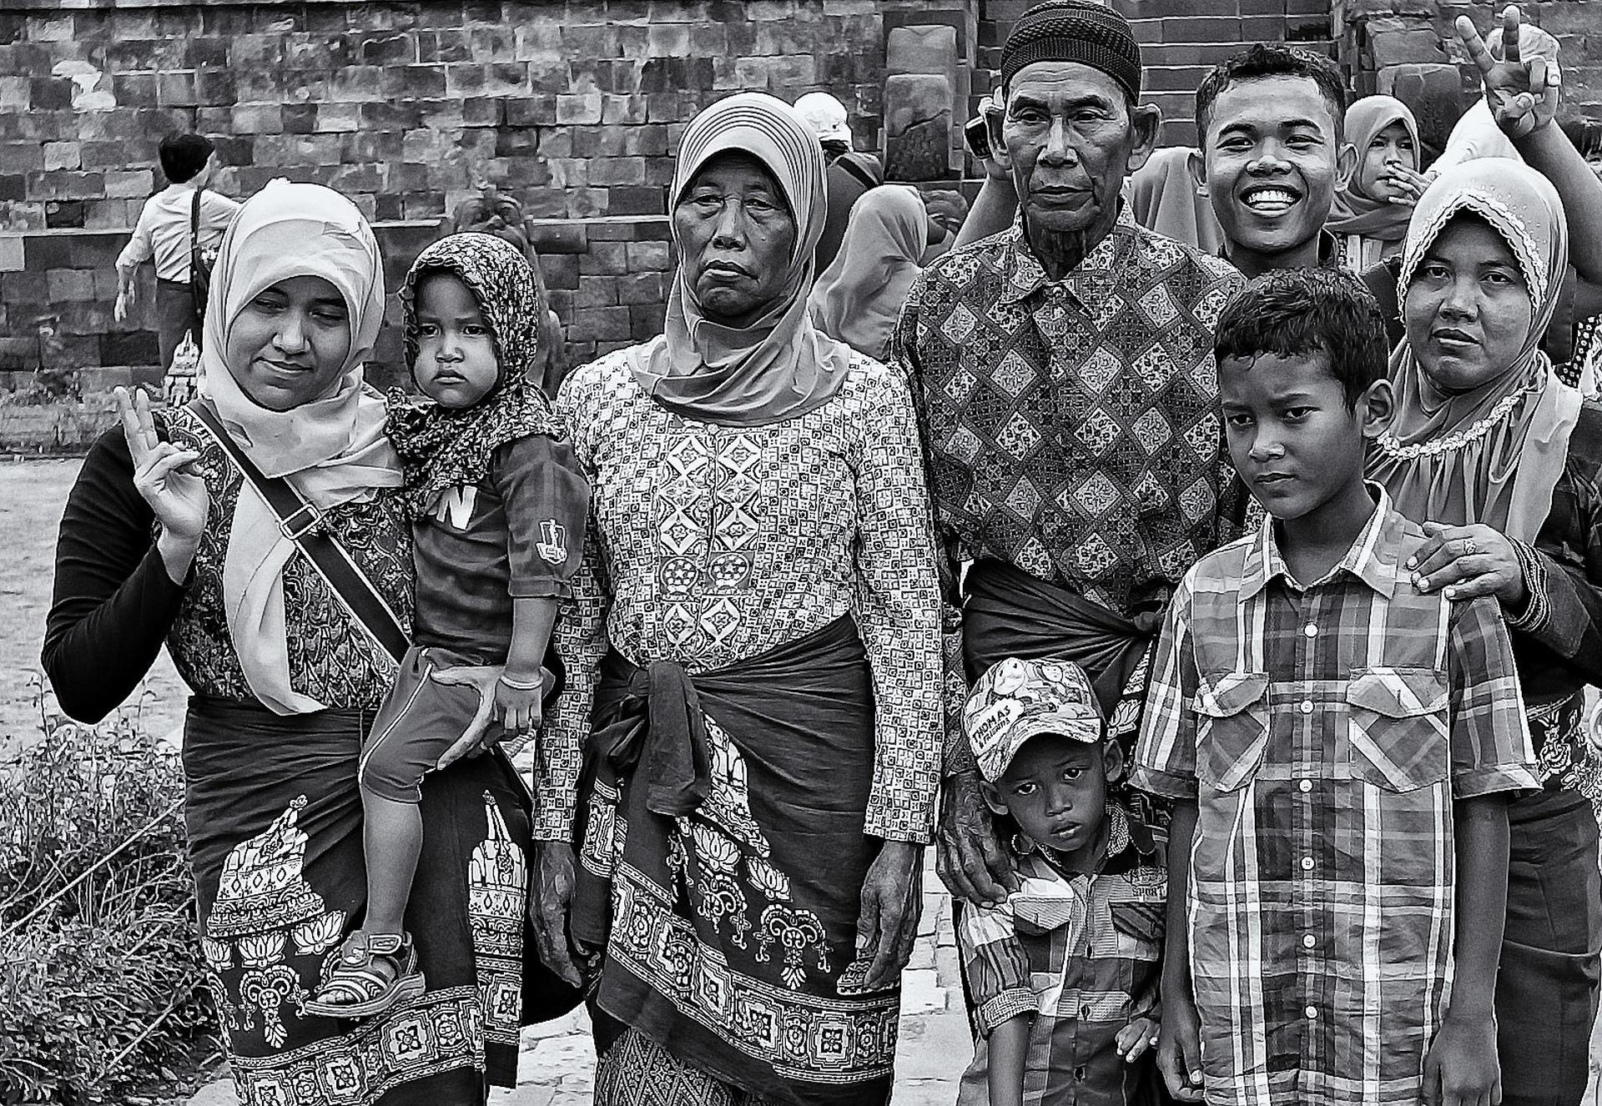  Picture F
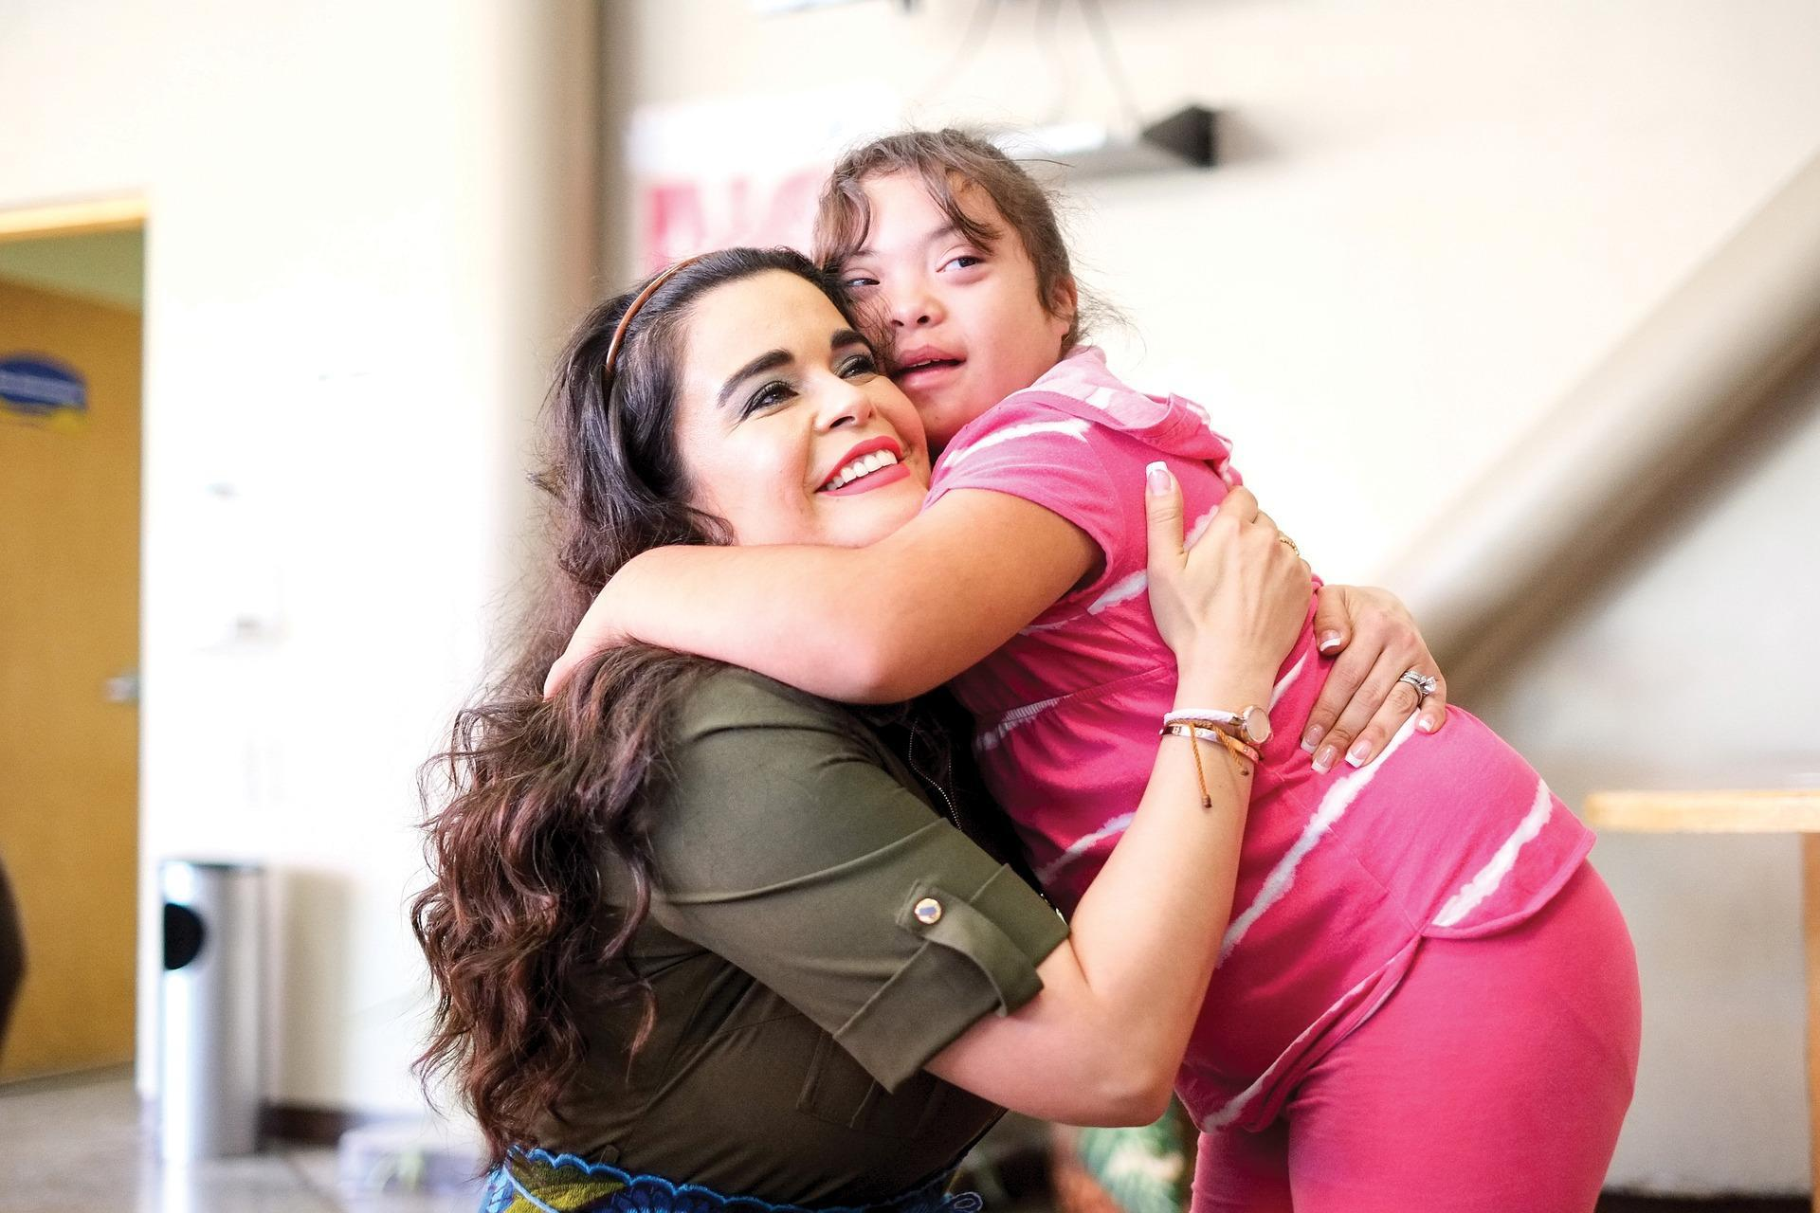  Picture G | 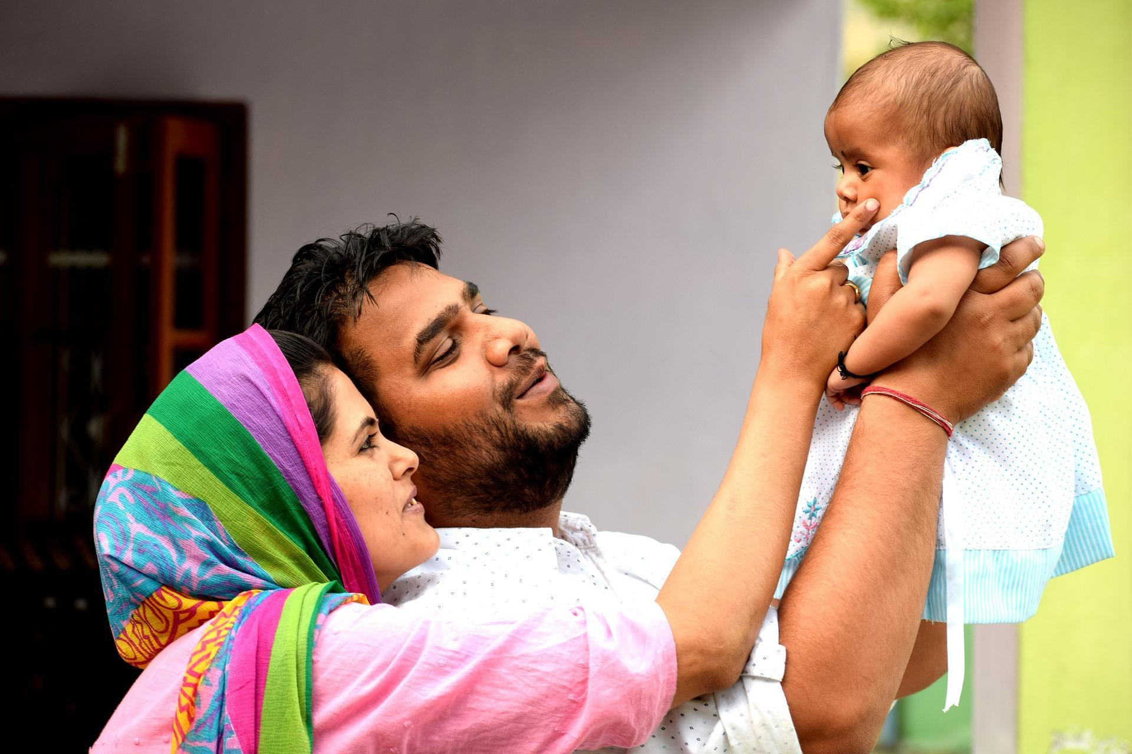  Picture H

Appendix 2: Maya’s story (transcript)

My family back home is really different to my foster family. I grew up and lived with my aunts, uncles and cousins. Our house was always busy. It was never quiet. My cousins and I had such fun playing together. My mum and aunts looked after us while my dad and uncles went to work. I know it’s strange here for people to live together with their extended family but it’s how we live in my country. It’s normal. Even though I was an only child I never felt alone as my cousins were just like brothers and sisters.
Since I’ve been in this country. I’ve lived with two different foster families. The first family was a typical nuclear family - two parents, two children, a dog and me. It was nice living there, but they moved abroad so they found me a new family. I love my new family. Rahul and Andrea have 3 children, Mansi, Nina and Hugo. They’re a little bit older than I am. They’re really friendly and make me feel part of their family. Rahul looks after the house and Andrea works in a hospital. We all get on really well. Things at home are not as noisy or hectic as they were in my family back home and to be honest, I really don’t miss living with so many family members. It does feel strange calling Rahul and Andrea mum and dad because they are really like my step-mum and dad, but I know my parents would understand.
One thing I have learnt is that families where I live now are all different and no one family is better than another.

