Teachers’ notes Level B.1.1

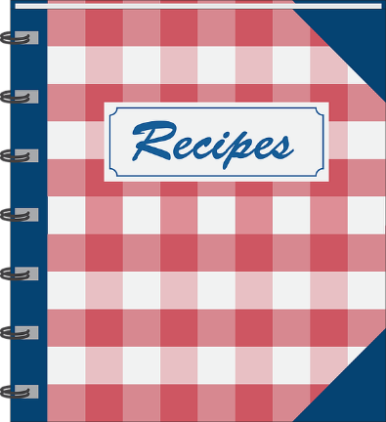
Lesson outcomes
By the end of the lesson students will have:
- talked about their favourite dishes from a different country.
- learned about their companions’ favourite dishes from a different country.
- worked together in groups in English, to decide the recipes that best represent their countries.
- written out at least one recipe.
- explained to the class how to make it.

Materials
Handout for students
Appendices
PPT
All images taken from Pixabay.com

Time | Procedure | Materials
5 minutes | Activity 1: Class discussion.  - Display lesson objectives.  - Students talk about the dishes they are used to eating at home with their families, the most popular street food where they lived before and which recipes they would like to share with the group. | PPT
10 minutes  25 minutes  10 minutes  5 minutes  (+ a later lesson) | Activity 2: Listening  - The teacher talks through an example recipe. There are 3 examples on the ppt. Two are Italian “favourites”, one with pork cheek and one vegetarian pasta sauce. There is also one typically British dessert with summer fruits.  - Make it clear that the written recipe is concise, the verbs in the imperative form.  Refer students to the language box for the typical written format for recipe methods. The spoken form can be much more relaxed and informal.  Activity 3: Groupwork  - Divide the students into mixed nationality groups where possible.  - They decide together the recipes they want to present.  - First they should write the recipes, then they could record themselves describing the method.  - The teacher must monitor and help with vocabulary while they are working. Remember in the written format the language is concise, the spoken version is more informal, more relaxed.  - Tell the students to prepare handouts of the recipes, including a photo, list of ingredients and the method.  Activity 4 : Explaining procedure  - Each group explains their recipe or recipes, while the others listen and take notes.  - The handouts of their recipes are now distributed. Give everyone time to check their notes and correct or complete them if necessary.  Activity 5: Consolidation  - Create a class recipe booklet.  - Put together the lists of ingredients, methods, a photo of each dish and a recording and/or video of the spoken instructions.  Nb. Clearly this cannot be completed in this project lesson, but if the class is motivated, it could be done at home or in a later lesson.
5 minutes | Reflection: Comparing  - Ask students to compare their recipes.  - Can some dishes be found everywhere?  - Has anyone found these dishes in restaurants or on food stalls where they are living now?  If so, are they similar or different in flavour?  If different, what is different and why? (ask them to think about texture, flavour, ingredients and spices used etc).
Students’ handout

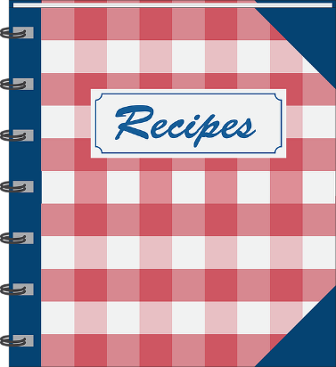
Lesson Outcomes
By the end of the lesson you will have:
- talked about your favourite dishes from your country.
- learned about your companions’ favourite dishes.
- worked together in groups in English, to decide the recipes that best represent your countries.
- written out at least one recipe.
- explained to the class how to make it.

Activity 1: Discussion
- Talk together about the dishes you are used to eating at home with your families, the most popular street food where they lived before and which recipes you would like to share with the group.
Activity 2: Listening
- Listen to the description of an example recipe.
- There are 3 examples on the ppt, two Italian “favourites”, one with a vegetarian pasta sauce, and one typically British dessert.
- Look at the language box for the typical written format for recipe methods. The spoken form can be more relaxed and informal.
Activity 3: Groupwork
- Divide into small mixed-nationality groups where possible.
- Decide together the recipes you want to present.
- First write the recipes, then record yourselves describing the method.
- Ask the teacher to help with vocabulary. Remember in the written format the language is concise, the spoken version is more informal.
Activity 4 : Explaining procedure
- Prepare a handout with the recipes, including a photo, the ingredients and method.
- When it is your group’s turn, explain the recipe or recipes, while the others listen and take notes.
- Give out the handouts so your classmates can check that they have understood correctly.

Activity 5: Consolidation
- Create a class recipe booklet.
- Put together the lists of ingredients, methods, a photo of each dish and a recording and/or video of the spoken instructions.
Nb. You will need to finish this later or as homework. Decide with your teacher.
Reflection: Comparing
- Ask students to compare their recipes.
- Can some dishes be found everywhere?
- Has anyone found these dishes in restaurants or food stalls where they are living now?
If so, are they similar or different in flavour?
If different, what is different and why? (think about texture, flavour, ingredients and spices used etc).
Language Box:
Writing Recipes
Use the imperative form and short concise instructions:
eg. Sieve the flour, add the sugar, mix the ingredients together, leave the mixture to rest, bake for 25 minutes at 325 degrees C (gas mark 5).
Explaining recipes:
- Use sequencing, words and phrases eg. first, then, next, after that, at the end, finally ….
- Include a subject if you want to: eg. you/we
- Be a bit imprecise if you want to: eg. slightly/a bit, more or less, just (over/under), about, approximately, around, roughly ….
Quantities:
Gms = grams, kg = kilos, oz = ounces, lb = pounds (weight not money), a pinch (a small quantity held between the fingers), a teasp = a teaspoon, a tbsp = a tablespoon (25 gms approx).
Lt = a litre (for liquids), ml = millilitres, a drop ( a very small quantity usually of flavouring or colouring), drizzle = a sprinkle.
Glossary
Cutting (from large to small):
halve, quarter, slice, cube/dice, chop, crush, grate, mince

Mixing (from slowly to fast):
Fold, stir, mix, knead (for bread dough), beat, whisk.

Cooking methods:
bake, roast, stew (in the oven).
Boil, simmer, braise, fry, stirfry, bainmarie (on the stov
Appendix 1
SUMMER PUDDING

- 300 gms strawberries
- 250 gms blueberries
- 100 gms redcurrants
- 500 gms raspberries
- 175 gms brown sugar or white sugar
- 7 slices of bread

Method
- Dissolve the sugar in a little water on a low heat.
- Add the soft fruit (but not the strawberries) and heat gently for 2-3 minutes.
- Wet the bread in the fruit juice.
- Cover the sides and bottom of a ceramic bowl with the sliced bread.
- Fill the centre of the bowl with the fruit and cover the top with bread slices.
- Put a small plate on top of the bowl, and something heavy like a packet of flour or sugar.
- Cool overnight and serve turned out upside down, with fresh whipped cream.

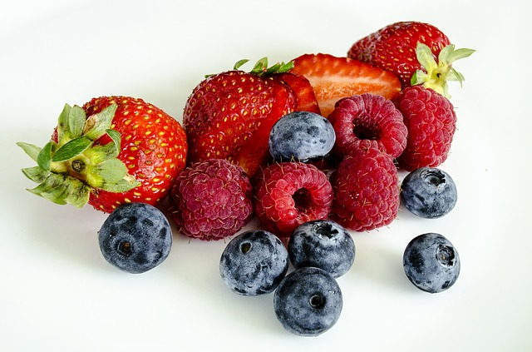

Appendix 2
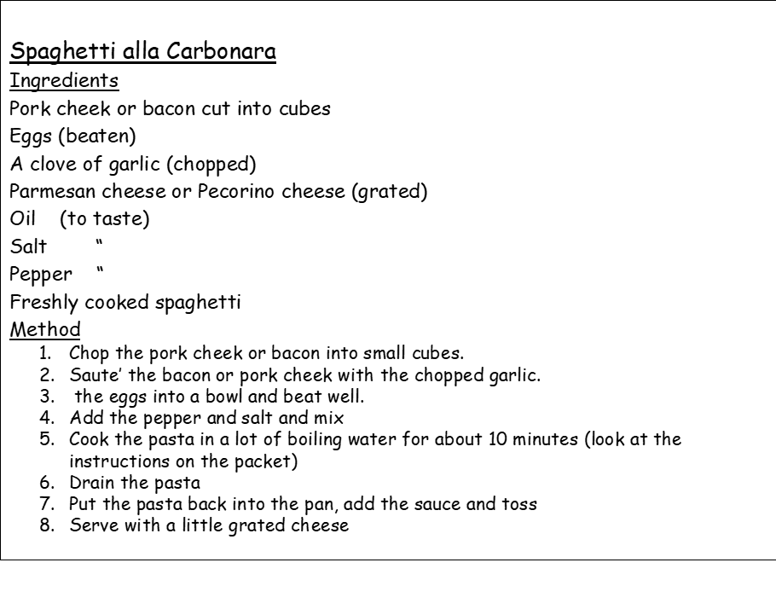
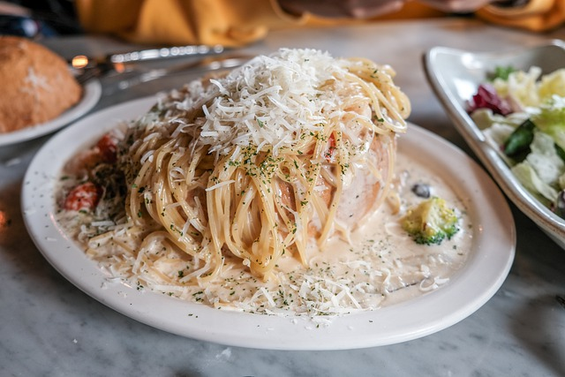

Appendix 3
Pasta with PESTO GENOVESE
Ingredients
fresh basil leaves
a clove of garlic
grated Pecorino or Parmesan cheese
pine nuts
extra virgin olive oil
rock salt
Method
- Clean the basil leaves.
- Peel the garlic.
- Put the basil, garlic, pine nuts, rock salt and a spoon of oil in a mortar.
- Crush together with a pestle until the mixture becomes creamy.
- Add grated cheese.
- Stir together
- Serve the sauce on freshly cooked pasta.

Alternatively, to save time, the basil, pine nuts, garlic, salt and oil can be mixed together in a blender.

