Teachers’ notes Level B1.1

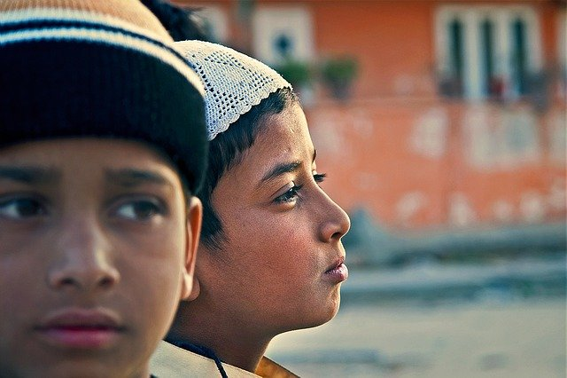
Lesson outcomes:
By the end of the lesson students will have:
- thought about having to go away from home.
- watched a real-life situation of young people fleeing their home country.
- imagined the journey they had to make and what they can do in the future.

Materials
Handout for students
Appendices
PPT
https://youtu.be/-QlHUcXQhf0
All images taken from Pixabay.com

Time | Procedure | Materials
5 minutes | Activity 1:  - Display lesson objectives.  - Ask students what experience they have of living away from their family?  - Has anyone actually had to leave home for any reason?  - How did they feel about it? | PPT
5  minutes  10 minutes  10 minutes  15  minutes  10  minutes | Activity 2: Vocabulary  - Tell students they are going to watch a short video of 2 brothers describing their experience. There are subtitles to read.  - Pre-teach some vocabulary:  UNCEF = The United Nations Children’s Fund (before, The United Nation’s International Children’s Emergency Fund)  To look after = (to take care of) and to look for = (to try to find); to care for (someone) = to like very much and help them; except for = all but one; to raise a family = to build a family; to hurt (someone) = to do something which damages them physically or mentally.  - Ask them to do the short vocabulary matching activity.  Answers: 1c; 2e; 3d; 4b; 5g; 6f; 7a.  Activity 3: Watch the video about Ali and Ahmed.  - How old are they? Why did they leave their home?  - In pairs or breakout rooms, students reconstruct their journey. Give them these words: Syria, Lesbos, Greece, Germany, Braunschweig children’s home. Encourage the use of sequencing devices (first of all, then, after that, at the end).  - Listen to their stories. Does everyone agree?  Activity 4: Watch the video again  - What do students think of the place Ali is staying, both the area and the building? Describe them! Are he and his brother lucky or unlucky to be there? Why?  Activity 5: Sharing ideas  - Divide the class into small groups. Tell them to think about what Ali and Ahmed should do now they are in Germany: a) if they have no money but just rely on the authorities for support.  b) if someone offers money to help them.  Ask them to prepare some ideas and advice. Eg. They could get in contact with the local church, volunteer and community groups working with people, land, gardens park and farms, charity shops, food banks or soup kitchens. They could help elderly people with cleaning, shopping, getting their medications, taking them to the doctor’s and so on. This kind of experience would help them to make friends, understand the community they are living in and prepare them for the world of work.  - Tell students to list their ideas in order of importance.  Activity 6: Describe.  Each group briefly describes their ideas. Allow students to comment briefly and ask questions. Eg. How practical are the ideas? Who do you need to contact, and what documentation is necessary to do something legally? What qualities and qualifications do you need to do something? Look at the lessons about volunteering for example, in this project.
5 minutes | Reflection  - Do they feel sympathy for Ali and Ahmed?  - How would they feel in their position?  - Would they do the same?  - What would they do differently and why?
Students’ handout

Lesson Outcomes

By the end of the lesson you will have:
- thought about having to go away from home.
- watched a real-life situation of young people fleeing their home country.
- imagined the journey they had to make and what they can do in the future.

Activity 1: Discuss
- Have any of you had any experience of living away from your family?
- Has anyone actually had to leave home for any reason?
How did you feel about it?
Activity 2: Vocabulary
- You are going to watch a short video of 2 brothers describing their experience. There are subtitles to read.
- First, look at this vocabulary:
- UNICEF; 2. to look after; 3. to look for; 4. to care for; 5. except for; 6. to raise a family; 7. to hurt (someone).
- Match the word or phrase above with the definition:
- To damage someone physically or mentally b) to like someone very much and to support them c) the United Nations Children’s Fund (previously the United Nations International Children’s Emergency Fund) d. to try to find e) to take care of someone f) to build a family g) to include all but one.

- b) c) d) e) f) g)

Check your answers with the teacher.
Activity 3: Watch the video about Ali and Ahmed.
- How old are they? Why did they leave their home?
- In pairs or breakout rooms, reconstruct their journey. Use these words: Syria, Lesbos, Greece, Germany, Braunschweig children’s home. Remember to use words and phrases like first of all, then, after that, at the end.
- Tell the story. Do all of you agree?

Activity 4: Watch the video again.
- What do you think of the place Ali is staying, both the area and the building? Describe them! Do you think he and his brother are lucky or unlucky to be there? Why?
Activity 5: Sharing ideas.
The teacher will divide you into groups.
- Think about what Ali and Ahmed can do now they are in Germany:
a) if they have no money but just depend on the authorities, eg, volunteer, find casual work….
b) if someone offers money to them, eg. study, start a business…..
- List your ideas in order of importance.

Activity 6: Describe.
Describe your ideas. Ask questions if you want to. Think about how practical the suggestions are. Think about the qualifications and personal qualities needed to do it successfully. Think about how these ideas will help with work in the future.

Reflection:
- Do you feel sympathy for Ali and Ahmed? Why? Why not?
- How would you feel in their position?
- Would you do the same?
- What would you do differently and why?

