Teachers’ notes Level B1.1

Lesson outcomes
By the end of the lesson students will have:
- talked together about everyday situations.
- discovered and practised ways of asking and answering politely, formally or informally, in situations important to their everyday life.

Materials
Handout for students
Appendices
PPT
All images taken from Pixabay.com

Time | Procedure | Materials
10 minutes  10 minutes | Activity 1: Every day  - Display lesson objectives  - What do students do every day?  - Give your day as an example.  Eg. Well, first of all, I take my children to school and then cycle about 3 kilometers to college. I almost always stop off at an Italian café for cappuccino and croissant but I try to arrive early to prepare my lessons. I teach my classes and then have a quick lunch in the canteen with students or colleagues. After college I often go shopping or sometimes go to the gym or swimming pool If I have time. I have to pick up the children from school if my partner is busy, but we always have dinner together at home.  - Now elicit other things from students and write them on the board.  Activity 2 : Comparing their day.  - Show the slides of various daily activities, at home, travelling, working and studying, having fun and free time activities.  - Distribute a handout of the photos if it is easier.  - Students can now work in pairs to add to their lists of daily activities.  - Ask them to compare their typical day now and their average day where they lived before. What are the similarities and differences?  - Can they explain what is similar and what is different and why? | PPT
15 minutes  10  minutes  10 minutes | Activity 3: Asking questions  - In pairs or small groups, students choose 3 photos to think about.  - Are the situations formal? (eg.at the doctor’s) or informal? (eg. with friends at home). What are the questions we ask in those situations?  - Ask them to look at the language box.  Activity 4: Creating dialogues  - Students now write some questions using the phrases from the language box.  - Ask them to create short dialogues using these questions and inventing suitable answers, descriptions or explanations.  Activity 5: Speaking  - All together, each group or pair presents a dialogue to go with one of the situations.
5 minutes | Reflection  - How do students feel about using formal and informal expressions?  - Do they feel embarrassed using formal language? Why?  - Is it easier to use informal language? Why?  - Do they consider formality unimportant? If so, when might we consider it important?  - Do they have formal language in their language? Is it used in the same way as English?

Students’ handout
Lesson Outcomes
By the end of the lesson you will have:
- talked together about everyday situations.
- discovered and practised ways of asking and answering politely, formally or informally, in situations important to your everyday life.
Activity 1: Every day
- What do you do every day?
- Listen to the teacher talk about his or her day. Make notes.
- Now suggest other things that you usually do every day.
Activity 2 : Comparing your day.
- Look at the slides of various daily activities, at home, travelling, working and studying, having fun and free time activities.
- Work in pairs to add to your lists of daily activities.
- Compare your typical day now and your average day where you lived before. What are the similarities and differences?
- Can you explain what is similar and what is different and why?
Activity 3: Asking questions
- Work in pairs, choose 3 photos to talk about together.
- Are the situations formal? (eg.at the doctor’s) or informal? (eg. with friends at home). What are the questions we ask in those situations?
- Now look at the language box.
Activity 4:
- Write some questions using the phrases from the language box.
- Make up short dialogues using these questions and inventing suitable answers, descriptions or explanations.
Activity 5: Speaking
- All together, each group or pair presents a dialogue to go with one of the situations.

Reflection
- How do you feel about using formal and informal expressions?
- Do you feel embarrassed using formal language? Why?
- Is it easier to use informal language? Why?
- Do you consider formality unimportant? If so, when might we consider it important?
- Do you have formal language in your language? Is it used in the same way as English?

Language Box:  More Informal questions and phrases:  Can I /you …. ?  Is it all right if / Is it okay if …?  Have you got …?  Have I got to …?  I want (to) ….  I need (to) …  eg. Can I get you anything? get=buy (at the supermarket))  Is it okay if I get a pizza? get=buy (at the take away)  Have you got any washing to take? have you got = have you? (to the laundrette)  Have I got to go to the police station? (have I got to=must I?)  I want a return ticket (at the station)  I need to get to 53 Cypress Avenue. What’s the likely cost? (at the taxi stand) | More Formal questions and phrases:  Could I/you …?  Could you tell me …?  Do you know if/where/when …?  Do you mind/would you mind … ?  Have you any idea (how much) ….?  May I …?  Would you …?  I’d like/ I’d really like to ….  eg. Could I make an appointment? (at the doctor’s)  Do you mind if I change my appointment? (at the hairdresser’s or doctor’s)  Have you any idea how much a single ticket to Rome costs? (asking information about trains)  May I do my homework with you please? (at college)  I’d like to send this parcel to Greece. Could you possibly weigh it for me? (at the post office)  Excuse me, I’m looking for a travel book about India. (in the library)

Appendix 1
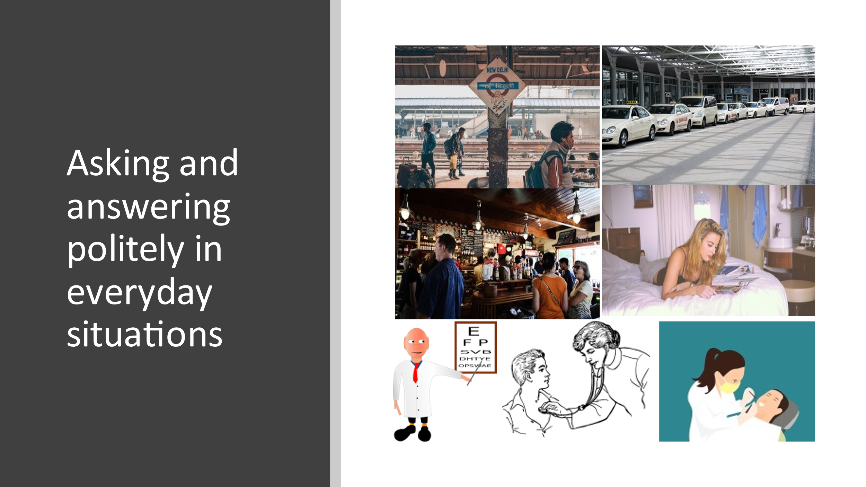
- In the station, at the airport taxi stand, in the pub, at home, at the opticians, at the doctor’s, at the dentist’s.
Appendix 2
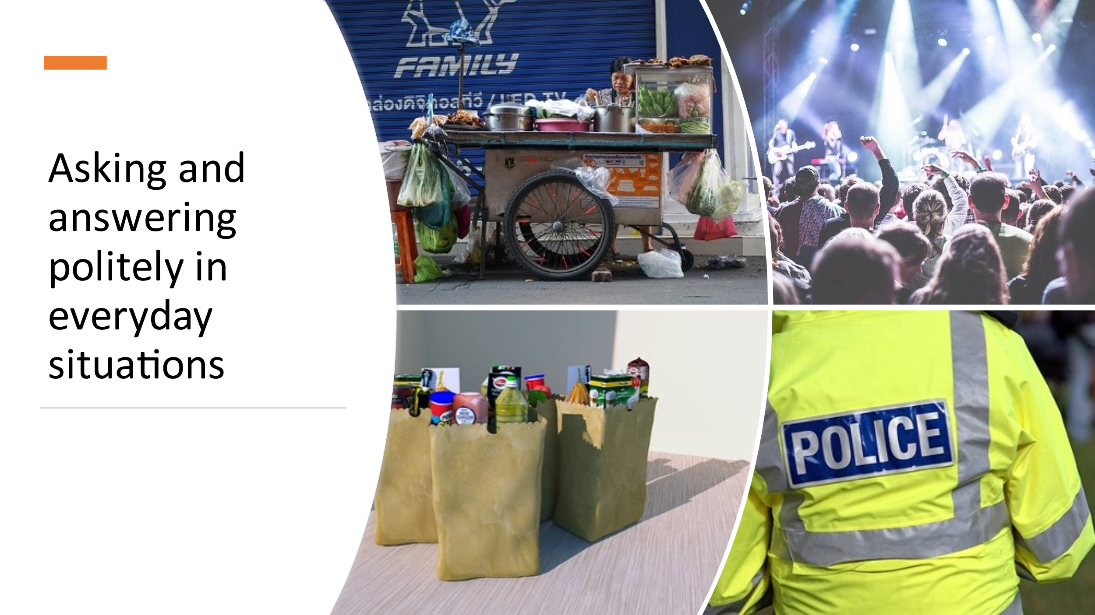

2. At the street-food stall, at a concert, shopping, at the police station or talking to the police.

Appendix 3

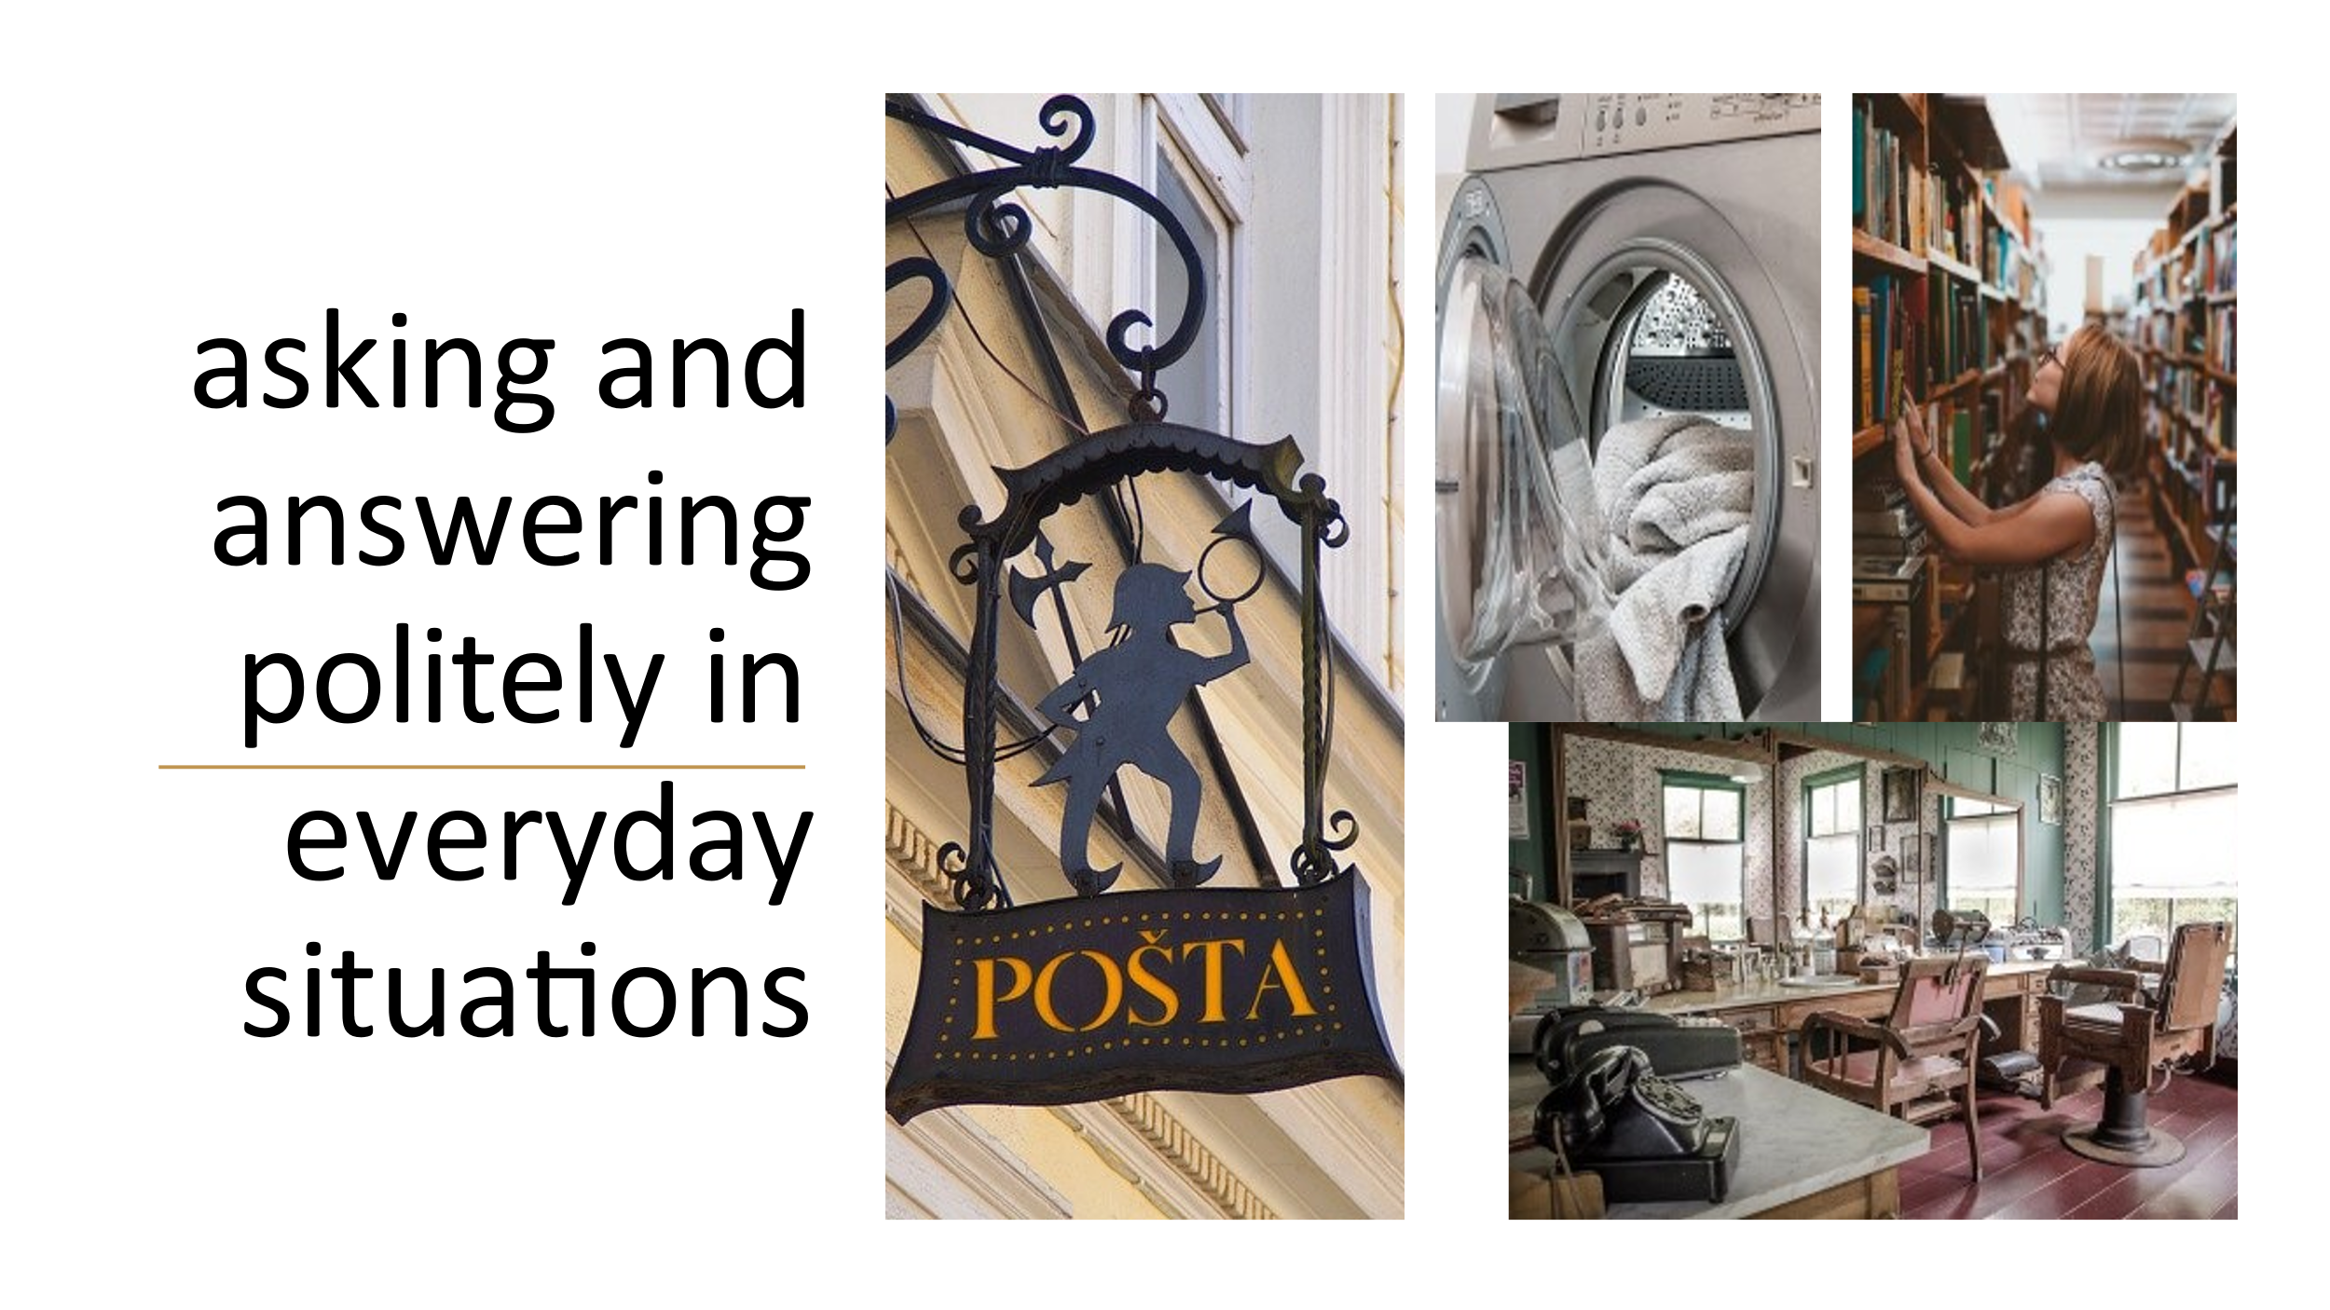

- At the post office, at the laundrette, at the library, at the hairdresser’s or barber’s

Appendix 4
Example everyday routine

Well, first of all, I take my children to school and then cycle about 3 kilometers to college. I almost always stop off at an Italian café for cappuccino and croissant but I try to arrive early to prepare my lessons. I teach my classes and then have a quick lunch in the canteen with students or colleagues. After college I often go shopping or sometimes go to the gym or swimming pool If I have time. I have to pick up the children from school if my partner is busy, but we always have dinner together at home.

