Teachers’ notes
Work Knowing your Rights B1.3
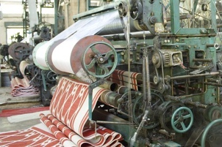
Learning outcomes
By the end of the lesson students will have:
- listened, taken notes on and discussed one woman’s story about being sacked
- focused on work- related vocabulary
- rewritten the story using the new vocabulary

Materials
Student handout / PPT
All images from www.pixabay.com
Appendix 1: Mayra’s story

Time | Procedure | Materials
5 mins | - Display and clarify learning outcomes | PPT
10-15 minutes | - Write two sentences on the board and ask the students whether they know the difference. ‘Arnie was made redundant last week.’ and ‘Susie was sacked last week.’ Explore the difference. Ask students which one is more preferable? Then tell them that they are going to listen to one person’s story about getting sacked from a job. Ask them to think about possible reasons someone might be sacked.  - Show students the questions that they need to answer after they have listened to the story and give them a couple of minutes to look at them. There may be some words in the questions they need to know before they listen i.e. trade union representative, tribunal. Briefly focus on these as the meaning should become clearer once the students have listened to the story. This vocabulary along with other employment related vocabulary will be focused on in Activity 2.  - Tell students that in addition to answering the questions, they need to take as many notes as possible about the story. Focus on the note-taking tips in the box to discuss how to take notes.  - Read the first couple of sentences of the story and ask students what sort of words they have written down to ensure they know how to make notes. Then finish reading the story.  - Put students into pairs / create breakout rooms to discuss the answers to the questions. Conduct whole class feedback.  Answers:  1. When she first found the job, Mayra was very happy. What did she like about the job?  It was regular hours and the pay was reasonable (the hourly rate was just above the minimum wage)  2. After a short time, she was unhappy with the job. What was the main problem she had with the job?  She was sometimes asked to do overtime at short notice and had no one to pick her children up from school and look after them  3. In what way did Beatriz, the trade union representative feel that the company was being unfair?  They were asking people to do overtime at short notice  4. How did the supervisor respond to Mayra’s explanation of why she couldn’t do overtime?  He said it wasn’t his problem and she had to do it. He also threatened to sack her.  5. What advice did Beatriz give Mayra the second time she spoke to her?  She suggested that she should take out a grievance against the company for unfair dismissal  6. Why did Mayra win the case against the company at the tribunal?  Because although they could legally ask her to work overtime without paying her extra to do it, they couldn’t ask her if it took her over the hours she had agreed in the contract she had signed. In this case, it did. | PPT  Activity 1
15 minutes | - Put students into new pairs / create breakout rooms and tell them they need to match the lexical items with their definitions. All items appear in the story which should help them.  - Conduct whole class feedback focusing on all aspects of the language i.e. meaning, pronunciation and form.  Answers  1-f, 2–d, 3–i, 4–j, 5–h, 6-k, 7–a, 8–l, 9–g, 1-b, 11–e, 12-c | PPT  Activity 2
20 minutes | - Put students into small groups of 3 / create breakout rooms and tell them that they need to remember as much information as possible about Mayra’s story using their notes, the answers to the questions and the vocabulary in Activity 2. They should work together to write the story. You could start by doing the first few lines of the story with them.  - Conduct feedback by getting different groups to read out sections of the story.  Extension activity: If you have a strong group and additional time, you could suggest that the students create their own stories using the vocabulary – they could either write the stories or tell them. | PPT  Activity 3
5 minutes | - The reflection asks them to reflect on whether they know anyone who has had difficulties in a work situation. It’s likely that if students come from different countries, they will have stories of poor working conditions. Similarly, they may know of people working in poor conditions in the country where they live now as many people often in low paid jobs are exploited. This could be something to explore with the class. You could also suggest that they do some research on how to challenge working conditions in different countries. | PPT  Activity 4

Work Knowing your Rights
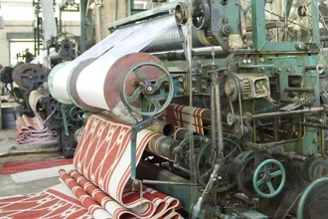
Learning outcomes
By the end of the lesson, you will have:
- listened, taken notes on and discussed one woman’s story about being sacked
- focused on work - related vocabulary
- rewritten the story using the new vocabulary

Activity 1: Mayra’s story
Before you listen to Mayra’s story, read the questions.
1. When she first found the job, Mayra was very happy. What did she like about the job?

2. After a short time, she was unhappy with the job. What was the main problem she had with the job?

3. In what way did Beatriz, the trade union representative feel that the company was being unfair?

4. How did the supervisor respond to Mayra’s explanation of why she couldn’t do overtime?

5. What advice did Beatriz give Mayra the second time she spoke to her?

6. Why did Mayra win the case against the company at the tribunal?

As you listen to the story, make notes on anything you her.
Note-taking
- Don’t write full sentences, only write content words such as nouns or verbs
- If there are words you don’t know, write down what you hear and check these later
- Make use of abbreviations e.g. bec = because, hrs = hrs
- Use symbols e.g. ü or X

Compare your answers in pairs.

Activity 2: Vocabulary
Work with a partner to match some of the vocabulary from the story with its definitions.

1) shift work |  | l) to remove someone from their job because of something they have done
2) minimum wage |  | g) a situation in which a person who has been asked to leave their job believes the decision was unfair
3) a contract |  | k) extra time spent working after the usual working hours
4) the shop floor |  | c) money that is paid to someone because they have been treated unfairly
5) a payslip |  | a) someone from the trade union who represents the employees’ by protecting their rights and discussing their pay and working conditions
6) overtime |  | d) the minimum pay per hour almost all workers are entitled to. This varies from country to country .
7) trade union representative |  | i) a written, legal agreement between an employer and employee with details of the job, working hours, pay etc.
8) to sack someone |  | j) the workers (not management) usually in a factory
9) unfair dismissal |  | h) a document given to employees with details of how much money they will be paid and what tax will be taken off
10) take out a grievance against an organisation or someone |  | f) a working pattern where employees work different times of the day or night
11) an employment tribunal |  | h) a document given to employees with details of how much money they will be paid and what tax will be taken off
12) compensation |  | b) a complaint that someone has been treated unfairly

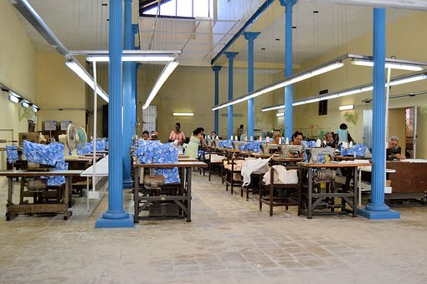
Activity 3: How much can you remember?
Work in small groups to rewrite Mayra’s story using the vocabulary from Activity 2.

Activity 4: Reflection
Do you know anyone who was treated unfairly at work? What was their story? Did they challenge the employer?
Although it can be free to take an employer to an employment tribunal in some places, if you lose the case, you might have to pay the employer’s legal costs. In your opinion, was Mayra right to take the company to an employment tribunal?
What do you know about challenging workers’ rights in different countries? Is it possible to do this in the country you are in now and any other countries that you know?
Activity 2 answers

l) to remove someone from their job because of something they have done
g) a situation in which a person who has been asked to leave their job believes the decision was unfair
k) extra time spent working after the usual working hours
c) money that is paid to someone because they have been treated unfairly
a) someone from the trade union who represents the employees’ by protecting their rights and discussing their pay and working conditions
d) the minimum pay per hour almost all workers are entitled to. This varies from country to country .
i) a written, legal agreement between an employer and employee with details of the job, working hours, pay etc.
j) the workers (not management) usually in a factory
h) a document given to employees with details of how much money they will be paid and what tax will be taken off
f) a working pattern where employees work different times of the day or night
h) a document given to employees with details of how much money they will be paid and what tax will be taken off
b) a complaint that someone has been treated unfairly

Appendix 1
Mayra’s story
Shortly after arriving in Portugal, Mayra found work in a textile factory. The job suited her because she wanted a job with regular hours rather than doing shift work as she needed to pick her children up from school every day after work. Her husband worked long hours on a building site so couldn’t be relied on to pick up the children. The hourly rate of pay was just above the minimum wage so she was pleased to have found this job.

Before starting work, she signed a contract but didn’t read it very carefully because it was so long. Not long after she started work, one of the supervisors came onto the shop floor and told everyone that they had a deadline to meet so they all had to stay late until the job was finished. She rang her aunt, the only person she knew who she trusted with her children and she agreed to pick them up from school and look after them until Mayra finished work.

When Mayra looked at her payslip at the end of the month, she was surprised to see she hadn’t been paid any extra for doing the overtime. A few weeks later, it happened again. She rang her aunt but as she was at work herself, she couldn’t pick up the children. Mayra told the supervisor, Jorge that she was unable to do the overtime. He was very unhappy and told her that if the company needed her to do overtime, she had to do it and if she didn’t, she would lose her job.

She was desperate so one of her colleagues suggested that she spoke to her trade union representative, Beatriz. Beatriz explained that the contract she had signed said that workers can be asked to work overtime with no additional pay at any time. However, they needed to be given reasonable notice about this. In her opinion, asking someone to stay to do overtime less than an hour before they had to do it was not reasonable so she suggested that Mayra spoke to the supervisor about this. She took Beatriz’s advice but he simply said she had to do the overtime when she was needed and they didn’t know in advance when this would be.

It happened again on two further occasions and both times, Mayra had to leave work to collect her children. After the last time it happened, she came into work the next day and Jorge told her they wanted her to leave and sacked her on the spot. Once again, she spoke to Beatriz, who said she thought she had been unfairly dismissed. She suggested that Mayra took out a took out a grievance against the company and explained that her case would be heard at an employment tribunal. It took some time but eventually Mayra won the case and was paid compensation for unfair dismissal. The tribunal agreed that although the company could legally ask their workers to work overtime without paying them any extra money, they couldn’t ask people to work longer hours than was agreed in the contract they signed. In this case, working overtime would have resulted in Mayra working more than 40 hours which is what her contract said she had to work each week. She told her former colleagues that they too should refuse to do the overtime!

