Teachers’ notes Level B.1.1

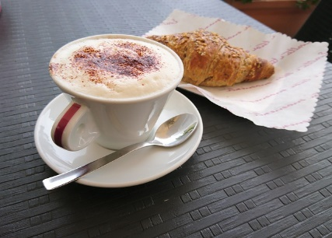
Lesson outcomes
By the end of the lesson students will have:
- practised food vocabulary
- noticed how recipe methods are expressed in English.
- created their own recipes using the same linguistic style
- understood more about each other’s lifestyles

Materials
Handout for students
Appendices as applicable
PPT
All images taken from Pixabay.com

Time | Procedure | Materials
5 minutes | Activity 1: Class discussion  - Display and clarify session objectives  - Ask the students:  - Do you eat in the morning? What do you eat? What do people in your family usually eat for breakfast? | PPT
10 minutes  10 minutes  15 minutes  15 minutes | Activity 2: Matching  - Show the breakfasts displayed on the ppt. Listen briefly to students’ comments.  - Write up or dictate a list of countries. Scotland, Austria, Turkey, USA, Ireland, Germany, China, France, England.  - In pairs, students try to match the countries with the breakfasts displayed on the ppt. Nb. Some pictures can be attributed to more than one country – eg. the muesli. The “English” breakfast could be Irish or Scottish. The discussion is important.  - Give “results” (they are displayed on the PPT Slide). Top row left to right: USA, China, Turkey, Scotland/Ireland; bottom row left to right: England/Ireland/Scotland, France, Germany/Austria.  - Ask if they agree and if any of them have a similar breakfast.  Activity 3: Putting in order  - Students look at a breakfast recipe on the Ppt and in Appendix 1. The recipe instructions are not in order.  - Point out the expressions which describe sequencing and tell students to look at the language box.  - Ask them to work in pairs. Put the recipe into the correct order. Give a time limit of 5 minutes.  - Students report back to the teacher.  - Give them a printed copy of the right order (Appendix 2).  - Ask them to name the dish.  Finally tell them the name – scrambled eggs - so they can write in the title on the printed copy.  Alternative: the recipe method can be printed, cut into strips and distributed for students to reorder.  Activity 4: Writing the recipe for a breakfast dish  - In pairs, students choose a simple breakfast dish that is popular in another country. Write out the ingredients and method to describe to the class.  - Check they use the same written style as the example.  - Tell them to practise the pronunciation and intonation in preparation for telling their classmates about it.  Activity 5: Speaking  - Each group explains their recipe to the class.
5 minutes | Activity 6: Reflection  - Are the dishes similar or different?  - Which ones would they like to taste? Why?  - Which ones wouldn’t they like to taste? Why not?  - Compare the breakfast here and in another country.  - Which do they prefer? Why?

Students’ handout

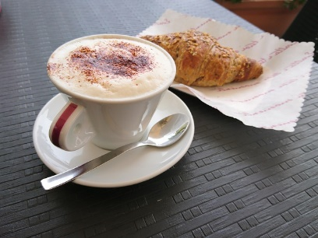
Lesson Outcomes
By the end of the lesson you will have:
- practised food vocabulary
- noticed how recipe methods are expressed in English.
- Written your own recipes using the same linguistic style
- understood more about each other’s lifestyles

Activity 1: Class discussion
- Do you eat in the morning? What do you eat?
- What do people in your family usually eat for breakfast?
Activity 2: Matching
- Look at the breakfasts on the ppt.
- In pairs, talk about what there is to eat and drink and where you think these breakfasts are from. You may disagree with each other.
- With your partner, match the countries in Appendix 1 with the breakfasts on the ppt.
- Go through the list together and with your teacher.
Activity 3: A breakfast dish Put in order:
- Look at the method for making the dish (Appendix 2). THE STEPS ARE NOT IN THE RIGHT ORDER.
- With your partner put them in order.
- Now check all together with the teacher and with a printed copy of the recipe.
- Look at the sequencing phrases in the language box.
- Can you give a name to the dish? Your teacher will tell you, so you can write the name on the printed copy.

Activity 4: Prepare a recipe
- In pairs, choose a simple breakfast dish that is popular in your country.
- Write out the ingredients and method to describe to the class.
- Make sure you use the same written style as the example.
- Practise the pronunciation and intonation ready to tell your classmates about Activity 5: Speaking
- Take turns to explain your recipe to the class.

Activity 6: Reflection
- Are the dishes similar or different?
- Which ones would you like to taste? Why?
- Which ones wouldn’t you like to taste? Why not?
- Compare the breakfast in this country and another country.
- Which do you prefer? Why?
- Choose a favourite dish.

Language Box:
Sequencing information
Sequencing phrases are useful when explaining or describing a process:
- First of all + imperative verb
+ subject and verb
- Then
- Next
- After that
- As soon as (+ subject + verb)
- Lastly/finally
Eg. First of all break the egg into a bowl …..
First of all you must break the egg into a bowl …..
As soon as the butter starts to melt …..
Finally add salt and pepper to taste ….

Glossary
Cooking terms
A knob of butter = a small piece of butter.
Add salt to taste = put in just enough salt to make the dish tasty.
To melt = liquify a solid (chocolate/butter/cheese).
To dissolve = make a solid disappear into liquid (ice/salt/instant coffee).
To beat = to mix very quicky.
To stir = to mix slowly and gently.
Appendix 1

Breakfast Recipe: Put in the correct order

A Place the pan on the lowest heat possible and put in a knob of butter.

B First of all, break the egg into a bowl and add the milk salt and pepper.

C As soon as the egg in the pan is thick and there is almost no liquid egg left, turn off the heat.

D Now keep stirring to continue the cooking. The heat in the pan will cook the egg to the right consistency

E Then stir the butter around the pan.

F After that beat the egg gently just to mix the ingredients.

G As soon as the butter starts to melt, pour in the egg.

H Keep stirring the egg in the pan with a spoon to mix the cooked egg with the uncooked part.

I Finally add salt and pepper to taste.

Appendix 2

Breakfast Recipe method IN ORDER

Breakfast Recipe: …………………………………………………….

B. First of all break the egg into a bowl and add the milk salt and pepper

F. Then beat the egg gently just to mix the ingredients.

A. Place the pan on the lowest heat possible and put in a knob of butter.

E. After that stir the butter around the pan.
.
G. As soon as the butter starts to melt, pour in the egg.

H Now keep stirring the egg in the pan with a spoon to mix the cooked egg with the uncooked part.

C. As soon as the egg in the pan is thick and there is almost no liquid egg left, turn off the heat.

D. Now keep stirring to continue the cooking. The heat in the pan will cook the egg to the right consistency

I. Finally add salt and pepper to taste.

