Teachers’ notes Level B1.2

Lesson outcomes
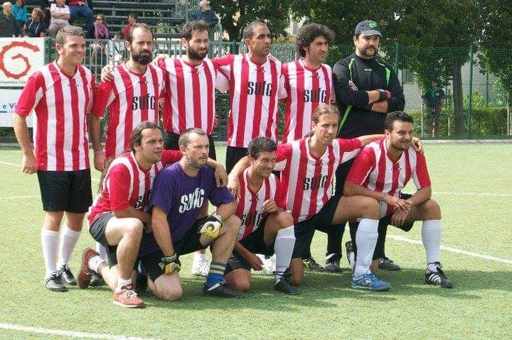
By the end of the lesson students will have:
- understood how to organise successfully a sports tournament.
- listened to the tournament organiser taken notes and used them to draw a plan.
- explained the organisation to each other.

Materials
Handout for students
Appendices
PPT
All images taken from Pixabay.com

Time | Procedure | Materials
5 minutes | Activity 1:  - Display lesson objectives.  - Put students into groups or breakout rooms for 3 minutes to brainstorm ways of encouraging the coming together of different nationalities through a common interest.  - Bring everyone together and listen to the ideas mentioned and experiences described. | PPT
15 minutes  15  minutes  10 minutes  10 minutes | Activity 2: Organising the tournament - listening  - The idea in this lesson is to explain the successful organisation of a multi-ethnic football tournament. In this case it was a boarding school setting where immigrants under 18 travelling without their families had been lodged.  - Vocabulary: special phrases the students need to know. Ask them to choose the correct definition in each case:  ~~~~~~~~~~~~~~~~~~~~~~~~~~~~~~~~~~~~~~~~~~~~~~~~~~~~~~~~  1)A 5-a-side football tournament a) If the score is 2-1 the winner scores 2  the loser scores 1.  2)It takes quite a long time. b) The 2 teams play together, one against the  other.  3)The winner and the loser c) There are only 5 players in each team, not 11.  4)The 2 teams played each other d) When the game finishes in a draw, each  team takes alternate shots at goal to decide the winner.  5)To take penalties e) The time needed (to organise) is considerable.  Answers: 1.c), 2.e), 3.a), 4.b), 5.d).  ~~~~~~~~~~~~~~~~~~~~~~~~~~~~~~~~~~~~~~~~~~~~~~~~~~~~~~~~~~~~~~~~~~~  - Ask students to listen to Mick (a 5-minute recording) and take notes about the way he organised this idea.  - Students discuss what he said together in pairs or groups.  - Invite them to listen again and discuss together what they have understood.  - Comprehension check: Ask students to work out how many matches there will be in Mick’s tournament. (10)  Activity 3: Draw a plan  - In their pairs or groups, students draw a plan of the organisation of the tournament as Mick described it.  - Tell them to think about the minimum number of matches a team can play in this tournament (2)  - How many matches would there be in a tournament if it were organised in 2 groups of 4 teams (minimum 13).  Activity 4: Practise explaining  - Students should practise explaining the organisation to each other including the order in which to play the matches. They have to use their plan to help them. Each member of the group, (or each one of a pair) should prepare to say something.  Activity 5: Explain  - Now the groups can take turns to explain their plan to the other students.  - Are their plans the same or different?  - Discuss the differences to understand which are right and which are not right or if both are possible.
5 minutes | Reflection  Discuss all together:  - Is sport an effective way to encourage friendship and integration? Why? Why not?  - What other ways can students suggest to encourage friendship and integration?

Students’ handout
Lesson Outcomes
By the end of the lesson you will have:
- understood how to organise successfully a sports tournament.
- listened to the tournament organiser.
- taken notes and used them to draw a plan.
- explained the organisation to each other.

Activity 1: Brainstorm
- In groups or breakout rooms brainstorm ways of bringing together of different nationalities through a common interest.
- Now all together, exchange some of the ideas you talked about.

Activity 2: Organising the tournament - listening
- The idea of this lesson is to explain the successful organisation of a multi-ethnic football tournament. In this case it was a boarding school setting where immigrants under the age of 18, travelling without their families, had been lodged.
~~~~~~~~~~~~~~~~~~~~~~~~~~~~~~~~~~~~~~~~~~~~~~~~~~~~~~~~~~~~~~~~~~~~~~~~~~~
Vocabulary: special phrases to know. Choose the correct definition in each case:
- A 5-a-side football tournament a) If the score is 2-1 the winner scores 2 the loser scores 1.
- It takes quite a long time. b) The 2 teams play together, one against the other.
- The winner and the loser c) There are only 5 players in each team, not 11.
- The 2 teams played each other d) When the game finishes in a draw, each team takes
alternate shots at the goal to decide the winner.
- To take penalties e) The time needed (to organise) is considerable.
~~~~~~~~~~~~~~~~~~~~~~~~~~~~~~~~~~~~~~~~~~~~~~~~~~~~~~~~~~~~~~~~~~~~~~~~~~
- Now listen to Mick and take notes about they way he organised the tournament.
- Discuss in your groups what Mick said.
- Listen again and take more notes.
- Comprehension check: Work out how many matches there will be in Mick’s tournament.
Activity 3: Draw a plan.
- In your pairs or groups, draw a plan of the organisation of the tournament as Mick described it.
- Think about the minimum number of matches a team can play in this tournament.
- How many matches would there be in a tournament if it were organised in 2 groups of 4 teams.
Activity 4: Practise explaining
- Practise explaining the organisation to each other including the order in which to play the matches. Use the plan to help you. Each member of the group, (or each one of a pair) should prepare to say something.
Activity 5: Explain
- Now take turns to explain your plan to the other students.
- Are the plans the same or different?
- Discuss the differences to understand which are right and which are not right or if both are possible.
Reflection Discuss all together:
- Is sport an effective way to encourage friendship and integration? Why? Why not?
- What other suggestions do you have to encourage friendship and integration?

