Teachers’ notes Level B.1.2.

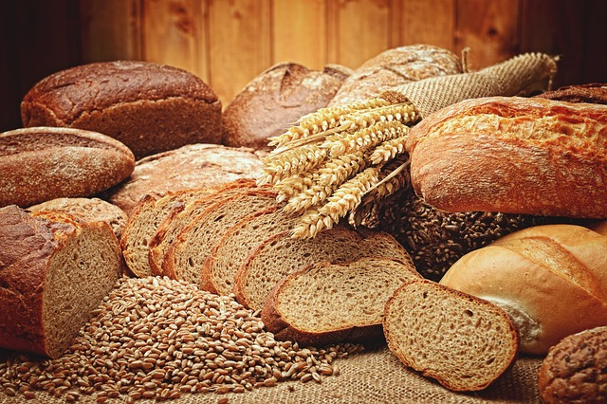
Lesson outcomes
By the end of the lesson students will have:
- developed their reading skills.
- been introduced to vocabulary for describing food and what it contains.
- been encouraged to make healthier choices when food shopping and menu’ planning.

Materials
PPT
https://www.nhs.uk/live-well/eat-well/
West Suffolk NHS Foundation Trust leaflet “Healthy eating for teenagers”
(https://www.nhs.uk/live-well/eat-well/healthy-eating-for-teens)
All pictures courtesy of Pixabay

Time | Procedure | Materials
5 minutes | Activity 1: lunch or dinner?  Show a slide of 2 meals (Appendix 1)  - Do they think these meals are dinner or lunch?  - Ask students to tell each other in pairs what they would eat for lunch and dinner.  - Compare answers. | PPT
10  minutes | Activity 2: Guessing and identifying  - Show students the word cloud and ask them to guess the reading topic.  - Work in pairs. Show the slides of foods containing sugar, protein, salt, saturated and unsaturated fats, examples of starchy foods and foods with fibre. Can they identify which is which? Do they recognise all these foods? Which do they usually eat?
20 minutes | Activity 3: Reading  - Tell students they are going to scan an nhs leaflet about a balanced diet.  - Read:https://www.nhs.uk/live-well/eat-well/  - Give them 5 minutes to read or listen to the article.  - Ask them to make notes, using keywords not complete sentences, about a balanced diet. Tell them not to translate!!  - In pairs, students now compare in theor own words, what they have learned about a balanced diet.  Variation: ask students to read the attached leaflet “Healthy eating for teenagers”.
10  Minutes  5 minutes | Activity 4: Worksheet 1 (Appendix 2)  - Individually, students complete the table about food they often eat, what it contains and whether it is healthy or unhealthy.  - Give students time to compare their ideas together in pairs or groups.  - Bring the group together and ask each of them to explain something they wrote about.  Activity 5 : Worksheet 2 (Appendix 3)  - Reading “testing” activity to consolidate the new vocabulary presented in this lesson.  - Students may work alone then compare together, but they will benefit more by working together in pairs or groups to “recycle” the new language.  Suggested answers:  - carbohydrates b. saturated fats c. unsaturated fats d. fibre e. salt  f. protein g. sugar h. fibre i. carbohydrates j. salt, (un) saturated fats  k. unsaturated fats l. fibre, unsaturated fats m. fibre n. fibre, protein o. protein p. saturated fats q. fibre r. protein s. unsaturated fats t. saturated fat
10 minutes | Reflection: What makes a balanced diet?  - Do the students eat a balanced diet?  - Did they eat a more, or less, balanced diet in the past?  - How could they change their diet to make it more balanced?

Lesson Outcomes
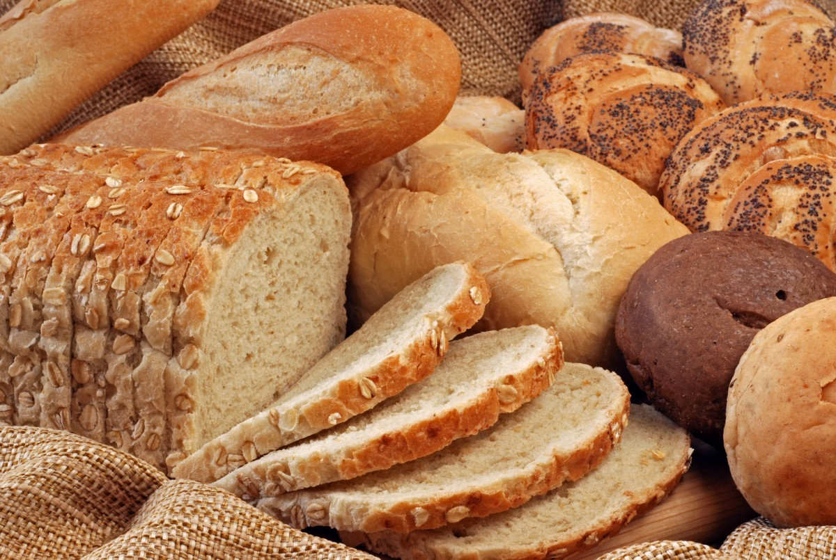

By the end of the lesson you will have:

- developed your reading skills.
- been introduced to vocabulary for describing food and what it contains.
- been encouraged to make healthier choices when food shopping and menu’ planning.

Activity 1: Compare and discuss.
- Look at the 2 photographs of hot meals.
- Do you think they are lunch or dinner? Why?
- What did you eat yesterday? What did you usually eat in your country for lunch and dinner?

Activity 2: Pre-reading Task
Work in pairs. Look at the word cloud. What is the topic of the reading passage?

WORD CLOUD

Salt sugar starchy foods calories balanced fibre vegetables protein saturated fats unsaturated fats healthy body weight wide variety

- Look at the slides of foods containing sugar, protein, salt, saturated and unsaturated fats, examples of starchy foods and foods with fibre. Can you identify which is which? Do you recognise all these foods? Which do you usually eat?

Activity 3: Reading
- Now read: https://www.nhs.uk/live-well/eat-well/
- You have 5 minutes to read or listen to the article. Do not translate!
- Make notes about a balanced diet using keywords and not complete sentences.
With your partner, compare what you have learned about a balanced diet.

Activity 4: Worksheet 1
- Individually, complete the table about food you often eat, what it contains and whether you think it is it is healthy or unhealthy.
Now compare together in pairs or groups.
Explain your choices to your teacher.

Activity 5 : Worksheet 2
- Sentence completion activity to consolidate the new vocabulary presented in this lesson.
- If you work alone to do this activity, compare together in pairs or threes to check our answers.

Reflection: What makes a balanced diet?
- Do you eat a balanced diet?
- Did you eat a more balanced or less balanced diet in the past?
- How could you change your diet to make it more balanced?

Glossary
Make sure you understand these words -

Balanced
Diet
Healthy
Body weight
Calories
Starchy food
Fibre
Protein
Carbohydrates
Saturated fats
Unsaturated fats

Appendix 1
Activity 1: Lunch or Dinner?

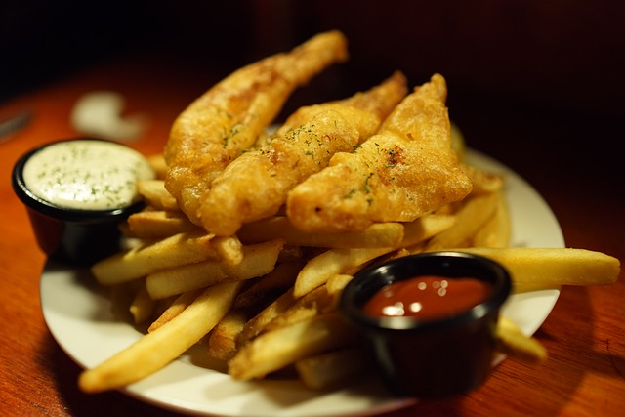

Appendix 2
Worksheet 1
Complete the table individually.

In the first column: write a list of food you often eat
In the second column: write what it contains.
In the third column: mark tick (/) if it is healthy, or cross (X) if it unhealthy.

Food you often eat | It contains a lot of…..  It is high in …….. | Is this healthy food?  Yes or no
Eg. chocolate | sugar, saturated fat | no

………………………………………………………………………………………

………………………………………………………………………………………

………………………………………………………………………………………

………………………………………………………………………………………

………………………………………………………………………………………

Appendix 3
Worksheet 2

Work individually

Use these words to complete the sentences below:

protein salt fibre carbohydrate sugar saturated fat unsaturated fat

Worksheet 2

Complete the sentences with one or more of the words above:

- White bread, white rice and potatoes are high in …………………………………
- Butter and cheese are high in ………………………………………………………
- Oily fish, salmon for example, is high in …………………………………………
- Brown rice and wholegrain bread are high in ……………………………………
- Salted nuts, cheese and olives brine are high in ………………………………
- Chicken beef and lamb are high in ……………………………………………………
- Chocolate is high in ………………………………………………………………………
- Oranges, lemons and tangerines are high in ………………………………………
- White spaghetti and gnocchi are high in ……………………………………………
- Potato crisps are high in ………………………………………………………………
- Avocados and avocado oil are high in ………………………………………………
- Almonds, walnuts, sesame seeds and other nuts and seeds are high in …………………………………………….
- Leafy vegetables like spinach and lettuce, are high in ……………………………
- Beans, chick peas and lentils are high in ……………………………………………
- Milk is high in ……………………………………………………………………………..
- Hamburgers (fried or grilled) are high in ……………………………………………
- Tropical fruits are high in ………………………………………………………………
- Eggs are high in …………………………………………………………………………
- Mackerel, sardines and anchovies are high in ……………………………………
- Fatty meat, sausages, bacon and kebabs are high in ……………………………

