Teachers’ notes
Health and Wellbeing Sleeping Well B1.3
Learning outcomes
By the end of the lesson students will have:
- discussed things that aid and hinder sleep
- listened to a TED Talk, ‘6 tips for better sleep’
- conducted research into what support is available where they live and produced a document with contact details

Materials
Student handout / PPT
TED TALK - https://www.ted.com/talks/matt_walker_6_tips_for_better_sleep
All images taken from Pixabay.com

Time | Procedure | Materials
5 minutes | - Display and clarify lesson objectives | PPT
5-10 minutes | - Find out who in the class slept well the previous night or didn’t sleep so well. Depending on the group they may or may not wish to offer reasons for this.  - Share a story about someone’s bedtime routine and elicit whether they think the person’s routine is likely to lead to a good night’s sleep e.g. has a hot chocolate, plays computer games and then goes onto social media sites.  Elicit reasons why this person may or may not sleep well.  - Display slide with images (slide 2) and ask students to discuss with their partner whether they think the different images lead to a good night’s sleep or not. Conduct whole class feedback and encourage students to explain their decisions.  [Suggested answers - Good night’s sleep - reading, darkness, cool room, calming music, hot bath Bad night’s sleep - screen time, exercise, caffeine, alcohol] | Board  PPT  Activity 1
10  minutes | - Place students into teams. Explain that they will have a set number of minutes to unscramble some common words connected to sleep and not being able to sleep. Dim is given as an example. These are words that students will hear in the listening. The final two are less common and may not be familiar to all students. Make sure the students don’t look at the next page on the handout where some of the words appear in the glossary.  [Answers 1. insomnia 2. darkness 3. temperature 4. trigger 5. caffeine 6. alcohol 7. regular 8. melatonin 9. sleep apnoea]  - Decide how long students have to complete the activity. Set a timer. You may wish to use a timer from classtools.net https://www.classtools.net/timer/  - Conduct whole class feedback. Focus on meaning, pronunciation and form. | PPT  Activity 2
15 minutes | - Explain that students are going to watch a TED Talk on 6 sleeping tips. The talk is approximately 5 minutes in length. Ask students to predict what tips the speaker may mention (they can think back to the previous lesson on sleep). Write the tips on the board so all students can see them as they watch the talk.  - Before students listen, explain that you want them to make notes as they listen to what they hear. Make sure all students have an understanding of what listening and note taking involves. Students can use the headings on their handout or may wish to produce their own notes.  - Play the talk. Place students in groups and ask them to see which of their tips Mat Walker mentions in his talk. Conduct brief whole class feedback  - Ask students to look at the true or false questions and to complete them using their notes. They can work with a partner to do this  [Answers:  a. F regular bedtime is important  b. T 18 degrees Celsius / 65 degrees Fahrenheit  c. F you can wear an eye mask if it helps  d. F you should get up after 25 mins and move around if you can’t sleep  e. F avoid caffeine in the afternoon/ don’t drink too much  f. T see a Dr if you think you have a sleep disorder]  - Conduct whole class feedback. Elicit what students think of the tips. Then find out if students know where they can go or what they can do if they are experiencing sleeplessness. | Board  PPT  Activity 3
15 | - Explain that students are going to conduct some research and compile a list of organisations, support groups, charities, helplines or communities that are available in their area for those experiencing difficulties with sleep. Depending on time you may wish to give students the name of an organisation etc to research. For example, in the UK the following all provide advice/ support for those who have difficulties sleeping [NHS support; Samaritans; Mental Health Foundation; Mind and Reading Well books].  - Students share the findings of their research. You may wish to produce a document that all students can access or print the list off for the classroom noticeboard.
5 minutes | Reflection  - Students can reflect on the questions individually or discuss them with a partner.  - Conduct whole class feedback | Activity 5  PPT

Health and Wellbeing Sleeping Well
Learning Outcome
By the end of the lesson you will have:
- talked about things that help and don’t help you sleep
- listened to a TED Talk – 6 tips for better sleep
- researched what support there is in your area for people who have difficulties sleeping

Activity 1: To sleep or not to sleep…
Look at the pictures below. Tick the ones which you think help people sleep and put a cross next to the ones which don’t help people sleep.
Compare your choices with your partner. Give reasons.

Activity 2: Guess the word
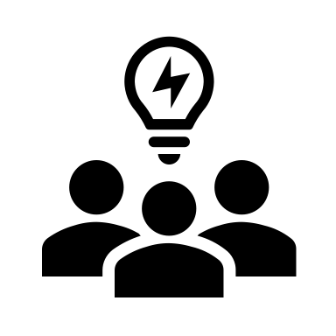
Your teacher will tell you how long you and your team members have to unscramble the words below. All the words are connected to sleep.
e.g. mdi dim (vb) to dim the lights
- Iomnnsai | i_______________ (n)
- resdsakn | d_______________(n)
- euapmerrtet | t_______________ (n)
- iggrert | t____________(vb)
- eiacffen | c_______________(n)
- ihoaolc | a__________ (n)
- laruegr | r__________ (adj)
- liaemnotn | m____________(n)
- lsepe anaepo | s_________ a________ ( n)

Glossary
insomnia - being unable to sleep over a period of time
trigger - something that causes something else to happen or start
caffeine - a chemical found in tea, coffee and drinks such as coca cola which makes people more active
melatonin - a hormone in the body that helps control sleep patterns
sleep disorder - any medical condition that stops people sleeping in a normal way
sleep apnoea - a medical condition which stops people breathing for a short time when they are sleeping
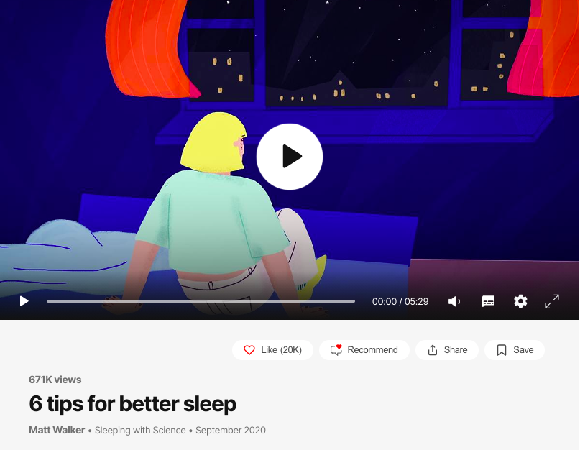
Activity 3: Matt Walker 6 tips for better sleep
3.1 You’re going to watch a TED Talk by a scientist called Matt Walker. He gives 6 tips for sleeping better. What do you think he might say?
3.2 Watch and listen to the talk. As you listen make notes.
Tip 1
Tip 2
Tip 3
Tip 4
Tip 5
Tip 6

3.3 Look at the following statements, Circle TRUE or FALSE

1. You should change the time you go to bed each night. TRUE / FALSE
2. You shouldn’t sleep in a very cold room. TRUE / FALSE
3. You should wear an eye mask. TRUE / FALSE
4. You shouldn’t stay in bed if you can’t get to sleep straightaway. TRUE / FALSE
5. You shouldn’t have alcohol or coffee before going to bed. TRUE / FALSE
6. You should see a professional if you have problems going to sleep. TRUE / FALSE

Activity 4: Reflection
Do you think you might change your bedtime routine to help you sleep better? Why? Why not?
Many people find it difficult to sleep, what advice can you give to someone who can’t sleep well?
There is a lot of support available for people who find it difficult to sleep. Have you heard of any of the organisations? What do you think of the support/ organisations?

