Teachers’ notes Level B1.1

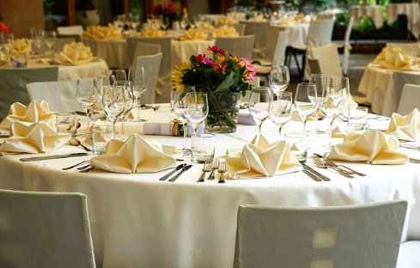
Lesson outcomes
By the end of the lesson students will have:
- talked about different foods in different countries.
- discovered and practised ways of asking and answering politely at the dining table.

Materials
Handout for students
Appendices
PPT
All images taken from Pixabay.com

Time | Procedure | Materials
10 minutes | Activity 1: Listing and comparing …. from what you know …  - Display lesson objectives.  - Working in pairs, ask students to list the food outlets in the area where they live, and the dishes they think are served there.  - Ask them to compare their lists all together. How many different cuisines have they mentioned? | PPT
10 minutes  5 minutes  10 minutes  20 minutes | Activity 2: Listing and comparing …. to what you don’t know …  - Give out a handout of a list of countries and example food vocabulary (Appendices 1 and 2). Make sure the students understand all the vocabulary.  - Show slides 2,3 and 4 on the ppt and ask them in pairs, to name the type of cuisine, ingredients and dishes probably available at each restaurant or food outlet shown. The ice cream parlour is an example.  - Tell them to add to the food lists on the handout.  - Go over the lists together and ask what they have tried before, what they like, what they don’t like and what they would like to try.  Activity 3: Asking questions 1  Give pairs 3 minutes to think of questions they often ask at the school or college self-service canteen, at a take-way food outlet or café’ every day,  eg. What is …..?_ Have you got …? …? Is it all right if …?  Can I ….? Is there …? Are there … ? How much ….?  Activity 4: Asking questions 2  - Now ask them to imagine that a family or someone they don’t know very well has invited them to dinner.  - How do we change the questions when we ask them?  - Tell the students to check the language box for examples.  Activity 5: At the dinner table  - In pairs or small groups, students quickly invent a dinner menu from the vocabulary shared in activity 2.  - What are the questions they might ask about …  - The menu b) the dishes c) something you need  (eg. condiments, sauces, cutlery, napkin, drinks)  - Write example questions using the language forms presented in the language box.  - Practise short dialogues together at the dinner table.  - Each pair or group present one dialogue to the others.
5 minutes | Reflection  - How do students feel about using these expressions?  - Do they feel embarrassed using them? Why?  - Do they think this language is unnecessary?  If so, why might we consider it important?  - Do they have equivalent polite forms in another language they know?

Students’ handout

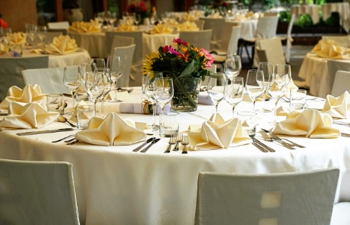
Lesson Outcomes
By the end of the lesson you will have:
- talked about different foods in different countries.
- discovered and practised ways of asking and answering politely at the dining table.

Activity 1: Listing and comparing …. from what you know …
- Work in pairs, list the food outlets in the area where you live, and the dishes you think are served there.
Compare your lists all together. How many different cuisines have you mentioned?
Activity 2: Listing and comparing …. to what you don’t know …
- The teacher will give you a handout of a list of countries and example food vocabulary. Make sure you understand all the vocabulary.
- Look at the slides on the ppt and in pairs, decide the type of cuisine, ingredients and dishes probably available at each of the restaurants or food outlets.
- The ice cream parlour is an example.
- Add names of foods and dishes to the lists on the handout.
- Go over them together. What have you already tried, what do you like, what don’t you like and what would you like to try?
Activity 3: Asking questions 1
- Think of the questions you most often ask at the school or college self-service canteen, at a take-way food outlet or café’ every day,
eg. What is …..?_ Have you got …? Is it all right if …? Can I ….? Is there …?
Are there … ? How much ….?

Activity 4: Asking questions 2
- Now imagine that a family or someone you don’t know very well has invited you to dinner.
- How do we change the questions when we ask them?
- Check the language box for examples.

Activity 5: At the dinner table
- Quickly invent a dinner menu from the vocabulary shared in activity 2.
- What are the questions you might ask your hosts about …
- The menu b) the dishes c) something you need (eg. condiments, sauces, cutlery, napkin, drinks)
- Write example questions using the language forms presented in the language box.
- Practise short dialogues together at the dinner table.
- Present one dialogue to the other
Activity 6: Reflection
- How do you feel about using these expressions?
- Do you feel embarrassed using them? Why?
- Do you think this language is unnecessary?
If so, why might we consider it important?
- Do you have equivalent polite forms in another language you know?

Language Box:  Ways of asking politely and agreeing:  Can I ….? Yes of course!  Could I ….? That’s fine!  Could I possibly …? Certainly!  Do you think I could …? Yes of course!  Do you mind/would you mind if I …? No not at all!  Nb.A polite negative answer typically gives a reason:  Well, the problem is ….. (+ reason)  I’m afraid ….. (+ reason)  Eg. Can I/could I have a glass of water please?  Could I possibly have some more bread please?  Do you mind if leave the sausage?  Do you think I could I possibly have some more chocolate mousse? Oh I’m afraid there isn’t any left! | Asking other people politely to do things:  Could you (possibly)…?  Do you think you could …?  Will you ..? would you ..?  Nb. Would you mind/ do you mind …? (Of course not!)  Eg. Would you mind passing the salt?  Could you possibly pass the red wine?  Do you mind passing the bread please?  Would you mind if I arrive a bit late?  Mind  Do/would you mind + verb + ing ….?  or  Do/would you mind + if + subject + verb …?  The answer is “Yes of course” or “No I’m sorry”

Appendix 1

Country Nationality
France French
India Indian
Italy Italian
China Chinese
North America American
Turkey Turkish
Greece Greek
Middle East Middle Eastern
Morocco Moroccan
United Kingdom/Great Britain English/Scottish/Welsh/British
Japan Japanese

Appendix 2
Vocabulary
Restaurants and examples of their national cuisine:
Italian – meat sauce, tomato sauce mozzarella/ricotta cheese, spaghetti, risotto, lasagne …..
British – cod, plaice, haddock, rock salmon (and chips), pies, bacon rolls, shepherd’s pie, apple pie and custard ……
United States - burger (hamburger, beefburger), fries, Caesar salad ……
Greek/Turkish – doner kebab, shish kebab, lamb, mutton ……
Chinese – pork, chicken, spring rolls, noodles, shrimps, prawns, sweet and sour sauce …..
Japanese - sushi, various types of tea ….
Indian - curry, rice, biriani, chapatti, nan …..
Nb. also:
Fast food - burgers, chips, fries, fish and chips, pizza …
Pub food - chicken pie, steak and kidney pie, bangers and mash, ploughman’s lunch, sticky toffee pudding ….
Take away (pizza, kebab etc) or eat in
Drive through (fast food outlet)
Self service restaurant (typically found in airports or factory canteens)

Canteen (factory/workers’ canteen) inexpensive basic warm meals

