Teachers’ notes
Relationships Marriage Trends B1.2
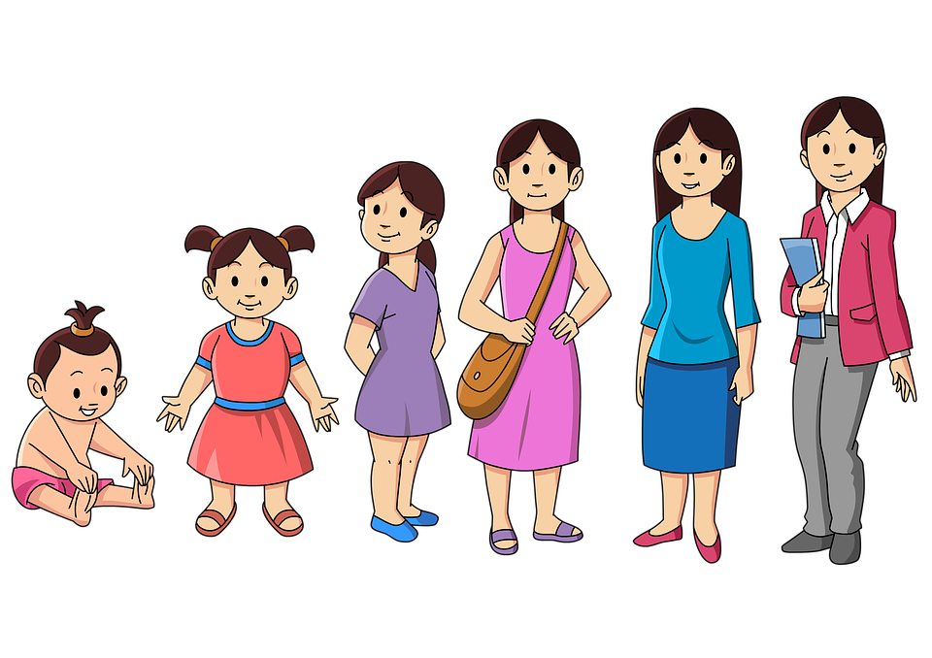
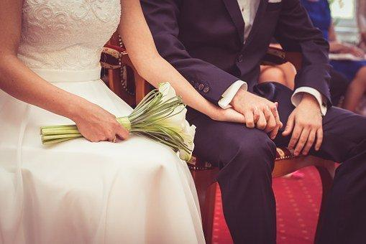
Learning outcomes
By the end of the lesson students will have:
- thought about their own attitude to marriage
- read about marriage in Europe
- compared marriage in different countries

Materials
Student handout / PPT
All images from www.pixabay.com
Information from:
https://ec.europa.eu/eurostat/statistics-explained/index.php?title=Marriage_and_divorce_statistics#Further_Eurostat_information
https://www.worldatlas.com/articles/the-nations-of-europe-by-the-average-age-at-first-marriage.html

Time | Procedure | Materials
5 minutes | - Display and clarify lesson objectives. | PPT
10 minutes | - Tell students they are going to talk about their own attitudes to marriage (which they started thinking about in the first lesson on marriage). There are 6 questions. Give students a number – this is the question they are doing research on. They need to move around the classroom asking as many people as possible their question. Suggest that they take notes.  - Then put them into groups of 6 to discuss their findings. Encourage them to use the sentence stems e.g. ‘A lot of us …’  - Conduct whole class feedback and find out whether anyone who comes from a different country has changed their views since they have been in their new country. | PPT  Activity 1
10 minutes | - Put students in pairs and tell them to decide whether the statements are True or False. Conduct whole class feedback.  [Answers:  1. Slovenia has the highest percentage of marriages per 100 people in Europe. FALSE (Cyprus)  2. Portugal has the highest divorce rate in Europe. TRUE  3. On average, people get married older in Eastern Europe (e.g. Moldova, Romania) rather than in other parts of Europe. FALSE – people get married younger in Eastern Europe  4. In most of the Nordic countries, about fewer than 20% of the women aged between 25 and 29 are married TRUE]  - Now that they have the correct answers, ask them to discuss the questions in b.  - Conduct whole class feedback.  [Suggested answers:  People want to have a career before getting married  People don’t think getting married is important any more – they can just live together  People think getting married is a waste of money and would rather use the money for something else  People want to live independently rather than getting married] | PPT Activity 2
15  minutes | - Tell students to read the text and set the task by asking whether any of the ideas they discussed in the last activity are mentioned. Tell students to check answers in pairs then conduct whole class feedback.  - Set the detailed reading task (the questions). Tell students to check answers in pairs then conduct whole class feedback.  [Answers:  1) The average age for a man to get married is 37.9 and 35.5 for  women.  2) No. There still quite a few countries where it is illegal  3) Yes, and this is becoming more common.  4) Yes, but this is becoming less common.  5) No. It is becoming less common.]  - Set the vocabulary task. Tell students to check answers in pairs then conduct whole class feedback.  [Answers:  Paragraph One: Begin to live a quieter life by getting married = settling down  Paragraph Two: Allowed by law = legal  Paragraph Three: Living together r= co-habiting….  Paragraph Four: Not allowed in law = illegal  Paragraph Five: Religion = faith] | PPT Activity 3
15 minutes | - Put students into groups of 3 and tell students they are going to compare the situation regarding marriage in 3 different countries. Encourage them to use the country they are living in now plus 2 others preferably that they have lived in. Tell them to complete the table possibly using information from the internet. Once they have the information, encourage them to use the language in the Language Box to discuss the similarities and differences.  - Conduct whole class feedback. | PPT Activity 4
5 minutes | Reflection  - Ask students whether they are surprised by anything they have discussed in the lesson.

Relationships Marriage Trends
Learning Outcomes
By the end of the lesson you will have:
- thought about your own attitude to marriage
- read about marriage in Europe
- compared marriage in different countries
Activity 1: Marriage, you and your classmates
a You are going to find out your classmates’ attitude to marriage. Your teacher will tell you which question to ask.
1 FIND OUT WHO …
knows somebody who has married a family member e.g. a cousin
2 FIND OUT WHO …
thinks it’s important to live with somebody before getting married
3 FIND OUT WHO …
has always wanted a big, special wedding day

4 FIND OUT WHO …
consider using a dating app to find a partner
6 FIND OUT WHO …
would be happy to have an arranged marriage
5 FIND OUT WHO …
would have children without being married

b Compare your findings in small groups. Finish the sentences below.

Most of us …
A lot of us …
If you have come from a different country, have your views changed since you came to your new country?

Hardly anyone …
None of us…
I was surprised that …

Activity 2: Marriage statistics
a Work in pairs. Do you think the statements are true or false?

1. Slovenia has the highest percentage of marriages per 100 people in Europe. TRUE / FALSE
2. Portugal has the highest divorce rate in Europe. TRUE / FALSE
3. On average, people get married older in Eastern Europe (e.g. Moldova, Romania) rather than in other parts of Europe. TRUE / FALSE
4. In most of the Nordic countries, about fewer than 20% of the women aged between 25 and 29 are married. TRUE / FALSE

b Answer the questions.
Why do you think there is a difference in marriage / divorce rates in different countries?
What affects the age at which people get married?
How do you think the figures might be different in other countries you know?

Activity 3: Marriage in Europe
Read the text below. Does it mention any of the ideas you discussed in Activity 3, Task 1 b?

Paragraph One
Nowadays, people in Europe are getting married at an older age. In the past it was quite common to see people getting married in their 20s. However, the age people are getting married now is gradually climbing. The average age for a man to get married is 37.9 and 35.5 for women. One reason for this is that people want to spend more time studying and working before getting married. Also, people want to spend time living independently before settling down.

Paragraph Two
Interestingly, people in same-sex marriages are usually a little older. However, this is based on the European countries where same sex marriages are legal as it is still not legal in all European countries. The average age for men in same-sex marriages is 40.8 and is 37.4 for women. This might be because it only became legal to marry someone of the same sex in 2014.

Paragraph Three
In the past it was also less common for people to live together before they got married. Now cohabiting is much more common and even people who are not planning to get married cohabit. They don’t believe that it is necessary to get married.

Paragraph Four
Arranged marriages take place in many European countries but they are becoming slightly less common. These are usually in Asian families – people from an Indian, Bangladeshi or Pakistani backgrounds. These should not be confused with ‘forced marriages’, which are when the couple getting married have no choice about getting married. These are illegal.

Paragraph Five
As for where people get married, this depends on their faith. However, fewer people are getting married in churches nowadays, and if you want to get married in a church, you usually need to attend marriage classes.

b Answer the questions
- What age do most Europeans get married?

- Can people of the same sex get married anywhere in Europe?

- Do people usually live together before they get married?

- Do arranged marriages take place in Europe?

- Is the number of people getting married in churches increasing?

c Match the words below to a word in the text. There is one word in each paragraph.
Paragraph One: Begin to live a quieter life by getting married ……………………….
Paragraph Two: Allowed by law ……………………….
Paragraph Three: Living together ……………………….
Paragraph Four: Not allowed in law ……………………….
Paragraph Five: Religion ……………………….

Activity 4: Making comparisons – marriage in different countries
Compare marriage in different countries. If necessary, do some research.

 | Name of Country: | Name of Country: | Name of Country:
What age do people usually get married?
Is same-sex marriage legal?

Do people live together before getting married?
Are arranged marriages common?
Where do people get married?

Language Box: Talking about similarities and differences
Discussing similarities  In all the countries…  Another thing these countries have in common is that…  For example: In all the countries the age people are getting married is increasing.  Another thing all the countries have in common is that same-sex marriages are legal. | Discussing differences  One difference is that…  Another difference is that…  For example:  One difference is that in XXX arranged marriages are not very common but in XXX they are.

